Release Notes
NECSWS.COM
Revenues & Benefits v6.27.0.0

Document Control
Software Version | Document Status | Document Revision | Issue date | Reason for change
6.27.0.0 | Published | 1.0 | 30/09/2021 | Released

© 2021-present day, NEC Software Solutions UK Limited or one of its group companies. This document is protected by copyright laws in England and other countries and must not be copied, stored in a retrieval system or transmitted in any form or by any means in whole or in part without the prior written permission of NEC Software Solutions UK Limited.

Table of Contents

Introduction 5
Installation 5
Prerequisites 5
Packaging 5
Documentation 5
Immediate Changes on Installation 6
Hot Fix Reminder 6
Hot fixes to be installed at this Release 6
Licencing Modules at this Release 6
Scripts Provided with this Release 7
Revenues Scripts 7
Benefit Scripts 7
CTR Scripts 7
Common Scripts 7
Order of Notes 7
Support and Maintenance for Bespoke Modules 8
Revenues New Functionality 9
WMS 159317: DWP have created new AOB outputs for different benefit types 9
WMS 159593: ONS have requested that account number is replaced with N/A 10
WMS 159736: If no parameters are entered, run for last extract only 11
WMS 159775: Replace .lis file with csv output (RRV218) 11
WMS 159776: RKC301 is posting payment recalls into Suspense where RRV340_CHK_DGT is Y 12
WMS 160198: Change report format to CSV (RRV431) 12
Council Tax Reduction New Functionality 13
WMS 158554: UC4CTR Review how unearned income can be automated 13
WMS 159399: Pandemic support payment (SCOTLAND) 13
Housing Benefit New Functionality 14
WMS 158239: Education Benefits clothing grants BACS file 14
WMS 159010: MAC claims may fail calc if not re-calc’d since 6.19.2.0 15
WMS 157672: HBAA IP capture for SHBE 15
WMS 159331: Change to the logic for SHBE IP address capture 15
Citizen Access Landlords and Information at Work 15
HBMS Rules – SHBE 15
Information Housing Benefit - WMS 160445: Wrong Capital Tariff for CL/PT aged 65 when 65+ capital tariff record exists 16
Common New Functionality 18
WMS 159032: Add ability to export report to csv file 18
WMS 159546: DPC validation differs for manually added deleted accounts 18
WMS 159936: I@W triggers created with incorrect naming convention leading to duplicates 18
WMS 160041: Scramble script deletes user job roles when scramble users set to N 18
Additional Modules Available 19
Release Notes Comment Form 20

Introduction
This document accompanies the RB6.27.0. release of NEC Revenues and Benefits. It details the enhancements to the product that have been made and the bugs that have been fixed at this release.
This version of the software supersedes all previously released versions. NEC policy is to withdraw support for previous versions six months after a new release.
This guide is intended for non-technical Revenues and Benefits staff and Systems Administrators.

Installation
An installer is provided with this release. Full installation notes for your platform are provided on the customer portal.

Prerequisites
These are detailed in the installation notes.

Packaging
This release and accompanying notes will be provided on the customer portal. The location will be detailed in the Software Release Bulletin.
Updated user guides referred to in the release notes will be placed in the user guide area of the customer portal.

Documentation
Product documentation provided with this release is as follows:
- Release Note - R&B_6.27.0_release_information_v1.0
- Release Note - R&B_6.27.0_ Bug_fix_release_notes_v1.0

Installation documentation provided with this release is as follows:
- Install Note - Install_6.27.0.0_ALL.docx
In addition, the following user guides have been issued with this release:
Product Area | User Guide – 6.27 version | Replaces User Guide version
Benefits User Guides | Education_Benefits_Northgate_Benefits v1.9 | Education_Benefits_Northgate_Benefits v1.8
Revenues User Guides | RMI326 User Guide - Notepad Loader V2.0  User Guide - REV - Credit Manager v1.4  User Guide - REV - EBills & Notices v10.0  User Guide – REV – ONS_Extract_RMI320 v3.0  REC318 AOB Spreadsheet for ESAJSA and IS v1.0 | RMI326 User Guide - Notepad Loader V1.0  User Guide - REV - Credit Manager  v1.3  User Guide - REV - EBills & Notices v9.0  User Guide – REV – ONS_Extract_RMI320 v2.0  N/A
CTR User Guides | N/A | N/A
Common User Guides | RB-I@W-Integration-v1.6 | RB-I@W-Integration-v1.5

Immediate Changes on Installation
This table shows a checklist of notable immediate changes on installation of this release. We recommend that you read the full release notes before using the release in a live environment.
Change | Detail | What should you do

Hot Fix Reminder
You are reminded that if you have recently applied a hot fix to ensure that this fix has been included in this release, please also check the Bug Fix List delivered with this release. If it is not included, then the hot fix will need to be re-applied.

Hot fixes to be installed at this Release
WMS | Detail

Licencing Modules at this Release
The following is an instruction of how to obtain and enable the licence for any of the new licenced modules at this release.
To Find Your Customer Id:
- Go to the System tab (SYSTEM-153).
- Go to System > Security.
- Go to Licenses (CORESEC-109).
- Search for the licence name for the area (see under each section in release notes below or see table in this section).
- Click on the Update icon next to the record.
- The Customer Id can be found here.
- Once you have provided the purchase order, raise a call on the customer portal giving your customer id and the name of the item (licence name) that you wish to have licenced. Customer Services will then generate a response key and email this back to you.
- To activate this functionality, insert the response key into the Key field and ensure that the "Enabled Ind" has been ticked.
- You can test your licence has been applied correctly by selecting the ‘Test Licence’ action that becomes available once you have selected the licence:
Licence Name | Description | Funding Arrangements
REC318 | This is a new data extract for DWP AOB for ESA/JSA and IS. | This is a licenced module.
CGPAYMNTBACSFORMAT | A new parameter has been provided to enable a new BACS payment file to be produced that can be sent directly to the bank rather than through a creditors system. | For further information please contact enquiries@necsws.com

Scripts Provided with this Release
These are new scripts that you will need to run after loading the release. They may relate to bug fixes or new areas of functionality. This will be explained in the main body of the notes. The scripts and links to their explanations can be found below:

Revenues Scripts
None

Benefit Scripts
WMS 159010: MAC claims may fail calc if not re-calc’d since 6.19.2.0
WMS 160445: Wrong Capital Tariff for CL/PT aged 65 when 65+ capital_tariff record exists

CTR Scripts
None

Common Scripts
None

Order of Notes
The user group executive has requested that release notes for new modules where a licence needs to be purchased, are provided separately from the main release notes. Any such items are listed in the "Additional Modules Available" section of this document.

Funded legislative items will remain in the main notes.

Support and Maintenance for Bespoke Modules
Please be aware that it is the customer’s responsibility to make sure that any previously installed bespoke modules are compatible with this new release. Any requests for support or maintenance resulting from incompatibility issues will be chargeable. NEC recommend that bespoke processes are tested before the release is installed into your live environment.

Revenues New Functionality
Summary and risk/test comments:
Enhancements | Summary of Changes | Risks & Recommendations
WMS 159317 | The DWP want Local Authorities to use a new format for cases that are JSA, ESA and IS. | Low as a standalone data extract.
WMS 159593 | The ONS output was changed to replace the account number with N/A | Low as standalone data extract
WMS 159736 | This process has been enhanced to pick up the last run only if no parameters are entered. | Low
WMS 159775 | RRV218 Transactions by Summary Group will now produce a csv file. | Low
WMS 159776 | A reminder that 'RRV340_CHK_DGT’ will validate check digit used by RRV340-Cash Receipts | Low
WMS 160198 | RRV431 Arrears Debt Stage by Account will be create a csv file in $ORBDATA. | Low

WMS 159317: DWP have created new AOB outputs for different benefit types
Local Authorities can set up attachment of benefits (AOB) on citizens on benefits that have arrears on their Council Tax.
The DWP want Local Authorities to use a new format for cases that are JSA, ESA and IS. The same format is applicable to each case but the file that the Local Authority send-off must only have cases from one benefit type.
A new data extract process called “REC318 AOB Spreadsheet for ESA/JSA and IS (2021)” is now available which will produce the following output.
Column | Column Description
Column A | Customer Reference Number
Column B | NINO
Column C | Date of Birth
Column D | Surname
Column E | Forename
Column F | Address
Column G | Postcode
Column H | Benefit Type
Column I | Liability order date
Column J | Court Name
Column K | Amount on liability order
Column L | Amount to be recovered
Column M | Accepted or Rejected (DWP use)
Column N | Start Date of Deduction (DWP use)
Column O | Rejection Reason (DWP use)
The new extract allows Local Authorities to:
- Run for benefit types ISA, JSA and ESA (these must be on a specified enforcement stage).
- Run using a from date.
- Set the number of max cases (accounts/claims) that are to be picked up
- Details are held in the tables, so they are not picked up again unless the extract is rerun.
- Rerun for a previous run
- Run for specific claims or accounts
- Show liability order id in the output
For further details refer to the “REC318 AOB Spreadsheet for ESA/JSA and IS (2021)” which is now available on the customer portal.
This is a chargeable/licenced option. Please contact enquiries@newsws.com for details.

WMS 159593: ONS have requested that account number is replaced with N/A
Further to Software Release Bulletin 689 dated 6th May 2021, we advised you that ONS were looking to remove the account number reference from the file.
The change was to replace the account number with N/A in the file as ONS did not want to alter the format of the file (i.e., by removing a column altogether).
This was issued under Software Release Bulletin 698 dated 2nd July 2021.
This change has been included in this release.
The user guide “User Guide – REV – ONS_Extract_RMI320 v3.0” has been changed to reflect this and is available on the customer portal.

WMS 159736: If no parameters are entered, run for last extract only
To improve performance for COL313 E-Notice Status Report, if no parameters are entered then the report will just return data for the last extract that was run. However, if parameters are entered the process will use these to determine the criteria of the data to be returned.
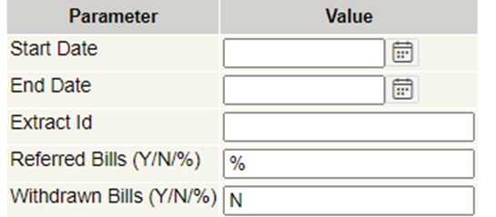
If the Local Authority wishes to look at historical data, then the start and end dates should be used.
The user guide “User Guide - REV - EBills & Notices v10.0” has been amended to reflect this and can be found on the customer portal.

WMS 159775: Replace .lis file with csv output (RRV218)
At this release to assist customers review the data, the .lis file for RRV218 Transactions by Summary Group will now produce a csv file.
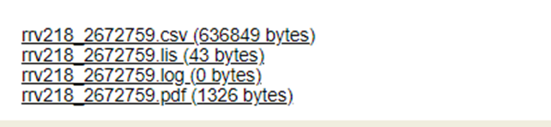
For example:
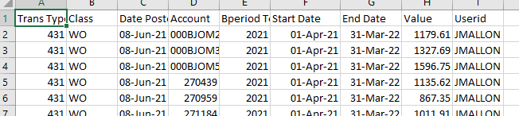

WMS 159776: RKC301 is posting payment recalls into Suspense where RRV340_CHK_DGT is Y
An issue was identified in Information Bulletin 1642 dated 24th May 2021 where this parameter was set to ‘Y’, when running RKC301 Process Arudd file’ the reversals are being allocated to suspense.
Below is a reminder from RB6.25 to remind customers how this parameter will work:
The system parameter 'RRV340_CHK_DGT’ which validate check digit used by RRV340-Cash Receipts
- If this is set to Y, then the check digit in the file is checked along with the account number. If the account isn't found, then the record is moved to Suspense (as per current).
- If 'N' or parameter not set, then the check digit isn't part of the validation and behaves as before.
- The Payment Receipting Interface Specification v2.2 has been updated to reflect this new parameter.
This was fixed under Software Release Bulletin 701 dated 13th July 2021 and has been included in this release.

WMS 160198: Change report format to CSV (RRV431)
At this release to assist customers review the data, the RRV431 Arrears Debt Stage by Account will create a csv file in $ORBDATA. For example:
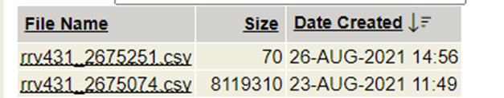
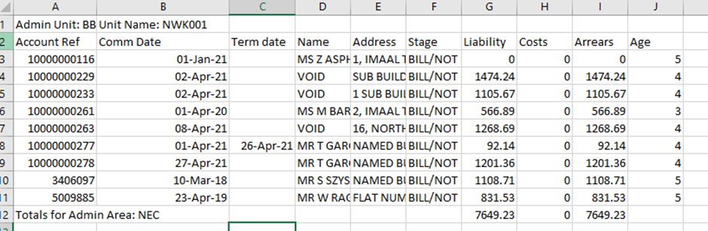

Council Tax Reduction New Functionality
Summary and risk/test comments:
Enhancements | Summary of Changes | Risks & Recommendations
WMS 158554 | UC Unearned income automation | Low
WMS 159399 | RMI330 has been created to extract details that meet the criteria for Scottish authorities. | Low

WMS 158554: UC4CTR Review how unearned income can be automated
This release includes an enhancement to the UC4CTR processing to allow for the inclusion of UC unearned income (where present) and the exclusion of individual incomes on the claim that could make up this amount within the calculation to ensure that no income is double counted. This will also ensure that LA’s don’t need to create or maintain an actual UC unearned income item type on the claims.
Customer meetings were held to agree the method by which these enhancements could be provided.
The release notes for the changes and the actions you need to take are currently being written and will be issued in due course.
If you need this information urgently in order to carry out testing now please contact the NEC customer services team for advice.

WMS 159399: Pandemic support payment (SCOTLAND)
A new batch process RMI330 has been created which will extract details held in the Revenues and Benefits system that meets the criteria outlined in Information Bulletin 1643 (issued 1st June 2021) for Scottish authorities.
Release notes, containing information on how to run the script can be found on the NEC Customer Portal https://customersupport.necsws.com/login/

Housing Benefit New Functionality
Summary and risk/test comments:
Enhancements | Summary of Changes | Risks & Recommendations
WMS 158239 | Changes to RBE699 to produce the BACs payment file directly rather than this being produced via a third party creditors system. | Low risk requires testing.
WMS 159010 | Script to address some claims failing calculation that are MAC | Low risk requires testing
WMS 157672 /159331 | No change to processes, IP addresses captured on Citizen Access will be included in SHBE including those captured with CA FCR | Low risk. The IP addresses will be included in the SHBE output
Information | RBC306 has been amended to send landlord details to I@W where they are identified as CA-LL landlords.
Information | Reminder to continually update DWP HBMS rules to match the current HBMS rule guide.
Information | Reminder that a script is available to update the CPA, LPA and SCA Allowance parameters to ensure the correct capital tariff values are used in calculating a claim moved from working age to pension age.

WMS 158239: Education Benefits clothing grants BACS file
Changes have been made to the RBE699 – Create Clothing Grants Payments process as agreed with East Renfrewshire, to produce the BACs payment file directly rather than this being produced via a third party creditors system.
Currently when the BACS payments? (Y/N/B, Yes/No/Both) parameter is set to B or Y, RBE699 (Create Clothing Grant Payments) produces file RBE385_nnn.DAT containing payment data for school uniform grants including bank details. This is intended for input to a third party creditors system.
A new parameter has been provided to enable a new BACS payment file to be produced that can be sent directly to the bank rather than through a creditors system.
For this parameter to work the licence key needs to be enabled by the support team. The licence key is CGPAYMNTBACSFORMAT.
Refer to the Education Benefits Guide v1.9 for further information.

WMS 159010: MAC claims may fail calc if not re-calc’d since 6.19.2.0
Mixed Age Couple claims were failing calculation even though claims had been active before mixed age couple’s legislation changed in 2019 so were transitionally protected. Any claims that have not been recalculated since release RB6.19.2 were failing calculation. This has now been fixed. The following script will identify the claims that need to be recalculated and will set the calculation flag.

WMS 157672: HBAA IP capture for SHBE
This information is also provided in the NES_R290 release notes and relates to customers using Citizen Access Full Case Review.
In line with new claims and change in circumstances submitted via CA-B, CA FCR submissions now include the IP address used which in turn is included in the SHBE return.
For more information about Citizen Access Full Case Review please contact enquiries@necsws.com

WMS 159331: Change to the logic for SHBE IP address capture
As part of the work for WMS157672 the issue whereby multiple (proxy) addresses and longer addresses were causing errors, have also been resolved. There are no changes on benefits to how the data is processed and used in SHBE.

Citizen Access Landlords and Information at Work
In RB6.26 we notified the CA-LL customers about exporting CA-LL documents to I@W. The notes are in the NOA_RB_121 release information document. The process RBC306 has been amended to send landlord details to I@W where they are identified as CA-LL landlords. The existence on a CALNOT notepad for the landlord is used for this purpose. Only customers using CA-LL should be using CALNOT notepads (which in turn set the ‘Citizen Access’ key detail) on R&B

HBMS Rules – SHBE
DWP has asked NEC to remind all LA’s that you should continually update your HBMS rules to match the current HBMS rule guide which is available on glass cubes.
The HBMS rules can be maintained under:
System > Setup > Revenues & Benefits > Benefits > Fraud / Fraud Case > Fraud Allegation where the list of HBMS Data Match reasons is held.
This is used in the Data Match field on the Interventions to say why the referral has been made.
DWP add to this list periodically, so you will need to make sure the list is set up correctly and is complete both now and in the future. The reference data is wholly manageable by yourselves, you can create/update and where a rule is suspended you can set to non-current so that the rule will not appear in the list of values for selection.

Information Housing Benefit - WMS 160445: Wrong Capital Tariff for CL/PT aged 65 when 65+ capital tariff record exists
Information bulletin 1658 issued on 24th August gave the following information. It is added again here for completion and also to advise that the script has been modified slightly to pick up all claims not just Active. You are advised to run the modified version of the script if you have had to correct your Capital Tariff parameters.
“At release 6.24, advice was provided on updating the CPA, LPA and SCA Allowance parameters to ensure the correct capital tariff values were used in calculation when a claim moved from working age to pension age. The advice stated that for CPA, LPA and SCA you were required to have a value in for the 60-64 age range and this should be the same as for the 65+ age range.
Following some recent calls from customers, we would like to make it clear that the age range split on your Capital Tariff parameters should be 59/60 and not 64/65. The calculation process uses 60 as a significant date then crosschecks against the Pension Delay table to determine when a person reaches State Pension Age.
If you have updated your Capital Tariff parameters to have the age ranges 0-64 and 65+, then the calculation process will not be able to correctly determine which should apply.
WMS 160445: WRONG CAPITAL TARIFF FOR CL/PT AGED 65 WHEN 65+ CAPITAL_TARIFF RECORD EXISTS was raised to develop a script to identify and flag affected claims for recalculation. This information will be included in the next release notes, please note that no code changes will be made as updating your parameters correctly is the resolution to this issue.
Customers should check their Capital Tariff parameters, and if you have age ranges 0-64 and 65+ then the following process should be followed to correctly update your parameters:

- Current 65+ Capital Tariff income should be deleted
- Current 0-64 Capital Tariff should be updated to 0-59
- Create new pension age Capital Tariff for 60+
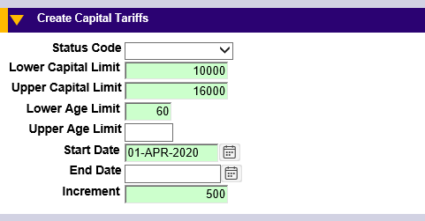

- Run the attached script in update mode
- The next run of RBE154B Mass Calc will re-calculate the reported claims with the correct tariff
The script can be run in report mode to list any affected claims, and update mode to flag them for calculation.

Common New Functionality
Summary and risk/test comments:
Enhancements | Summary of Changes | Risks & Recommendations
WMS 159032 | New Export to Spreadsheet link added to Task Summary and Task Search.
WMS 159546 | Error fixed around accounts manually added to a DPC control ID prelist.
WMS 159936 | Error fixed around I@W triggers being duplicated incorrectly.
WMS 160041 | User job roles are no longer deleted incorrectly.

WMS 159032: Add ability to export report to csv file
A new Export to Spreadsheet link has been added to the Task Summary page (CORETM-102) and the Task Search page (CORETM-205). On clicking this link, the user will be given the ability to export the relevant data to a csv file and save it to a location of their choosing. The csv file will contain all the columns and records in the report, reflecting any search.

WMS 159546: DPC validation differs for manually added deleted accounts
When an account has been manually added to a DPC control Id prelist, the processing of the manually added account throws an ‘Account Reference not found’ error and rejects the account from the run.
This has been fixed at this release.

WMS 159936: I@W triggers created with incorrect naming convention leading to duplicates
Information@Work triggers are created dynamically when RBC306 is run in FULL mode. In a previous version, changes were made to the ADDRESS_ELEMENTS trigger, that caused duplicate triggers to be created.
This has now been fixed at this release.

WMS 160041: Scramble script deletes user job roles when scramble users set to N
In a previous version, the scramble script was incorrectly deleting user job roles when the scramble users parameter was set to N. This has been fixed at this release as users will not be deleted when the parameter is set to N.

Additional Modules Available
Summary and risk/test comments:
Enhancements | Summary of Changes | Risks & Recommendations
N/A | N/A | N/A

Release Notes Comment Form
We welcome your comments and suggestions on the quality and usefulness of this document. Your input is an important part of the information used for revision.
We would be grateful if you could answer the following questions regarding this document:
- Did you find any errors?
- Was the information clearly presented?
- Was sufficient information provided?
- What features did you like most about this document?

If you have any suggestions for improvements, please indicate the section/subsection or items. If you wish to send an annotated copy of the relevant piece, this would be helpful.
Please email your comments to lynda.callaway@necsws.com

