NEC Housing User Guide
NECSWS.COM
Outlook 365 Integration

September 2021
Release 21.1.0 – 1.0

Confidentiality of Information
The information contained within this document (together with any explanatory or related information) is the intellectual property of NEC Software Solutions (NEC) and is provided in commercial confidence. All information contained within this document is confidential for a period of 7 years from the date of this document, and we request that this is not made available for public disclosure as this will prejudice the commercial interests of NEC. In the event of any request for disclosure being made under the Freedom of Information Act or similar legislation we would wish to be consulted prior to any information being disclosed.
Please note, none of the provisions contained within this document are intended to be legally binding.

© 2021-present day, NEC Software Solutions UK Limited or one of its group companies. This document is protected by copyright laws in England and other countries and must not be copied, stored in a retrieval system or transmitted in any form or by any means in whole or in part without the prior written permission of NEC Software Solutions UK Limited.

Table of Contents

Confidentiality of Information 2
1. Introduction 4
1.1 Scope of Document 4
1.2 Summary of functionality 4
1.3 New at this release 4
1.4 Related Documents 4
2 Functionality & Setup 5
2.1 Outbound Emails 5
2.2 Inbound Emails 6
2.2.1 Overview 6
2.2.2 System Parameters 7
2.2.3 First Reference Values (FRV) 8
2.2.4 Task Manager Configuration 8
2.2.5 Workflow File Creation 10
2.2.6 Start Inbound Poll 10
2.3 Outbound Appointments 11
2.4 Inbound Appointments 12
2.4.1 Cancelling Appointment 16
2.4.2 Move Appointment 16
2.4.3 Start Inbound Poll 17
3 Pluggable Authentication Modules (PAM) Configuration 18

1. Introduction

1.1 Scope of Document
This document describes the installation and configuration requirements for integration with NEC Housing and Outlook365.
The integration is supported with a Cloud installation of Outlook 365. Please refer to your Account Manager for further information.

1.2 Summary of functionality
The Outlook 365 integration provides the capability for:
- Outbound emails from NEC Housing
- Inbound emails to NEC Housing Task Manager
- Outbound NEC Appointments
- Inbound Outlook Calendar views and Updates to NEC Appointments
This functionality is available from v6.20 of NEC Housing, and requires a new Licence Key – called OUTLOOK365.
In addition to the licence Key we have introduced new system parameters to allow you to control which elements of the integration you deploy, these are:
- OUTLOOK365 - Set to Y to use Outlook 365 for Email and Calendars
- EMAILOUT_OUTLOOK365 - Enter Y to enable outbound email from NEC to Outlook365
- EMAILIN_OUTLOOK365 - Enter Y to enable inbound email from Outlook365 to NEC
- APPTOUT_OUTLOOK365 - Enter Y to enable outbound calendar integration appointments from NEC to Outlook365 Calendar
- APPTIN_OUTLOOK365 - Enter Y to enable inbound calendar integration appointments from Outlook365 Calendar to NEC.

1.3 New at this release
There have been no changes at this release.

1.4 Related Documents
Please also refer to:
- NEC Housing Outlook 365 Integration Technical Install.

2 Functionality & Setup

2.1 Outbound Emails
Outbound 365 outbound email integration is configured using standard DTI templates as for previous versions of Outbound emails.
In addition to installing the OUTLOOK 365 licence, and configuring the integration with Outlook 365 the system parameter EMAILOUT_OUTLOOK365 should be set to ‘Y’.
Parameter Name | EMAILOUT_OUTLOOK365
Description | NEC to Outlook365 Email
Required | N
Datatype | Yes / No
Default Value
Hint | Enter Y to enable outbound Email to Outlook365 mail
The system parameter of: EMO_EMAILADDR needs to be populated with the outbound email address for your organisation. This is the email address that will be shown to the customer on their email in the ‘From’ field. This email address must have the same domain name as your organisations Outlook 365 account.
Parameter Name | EMO_EMAILADDR
Description | From Email Address for messages
Required | N
Datatype | Text
Default Value | -
Hint | Enter from email address for sending external messages

There is also a requirement to configure the OAUTH2 integration between NEC Housing and Outlook365 as per section 3 of this document. This configuration would typically be carried out by your organisations Azure Portal Administrator, in conjunction with your NEC Database Administrator.

2.2 Inbound Emails

2.2.1 Overview
Inbound Outlook email integration with NEC uses NEC Housing Task Manager, which provides a ‘holding point’ for emails to allow for distribution / assignment to the relevant teams or individuals.
In addition to installing the OUTLOOK 365 licence, and configuring the integration with Outlook 365 the system parameter EMAILIN_OUTLOOK365 should be set to ‘Y’. Also the NEC Task Manager Licence and configuration needs to be applied.
Parameter Name | EMAILIN_OUTLOOK365
Description | Outlook365 Email to NEC
Required | N
Datatype | Yes / No
Default Value
Hint | Enter Y to enable inbound Email from Outlook365 mail
There is also a requirement to configure the OAUTH2 integration between NEC Housing and Outlook365 as per section 3 of this document. This configuration would typically be carried out by your organisations Azure Portal Administrator, in conjunction with your NEC Database Administrator.
The following is a high-level overview of the data flow:
- Email received in Organisations ‘Outlook 365 Inbox’
- NEC Integration with Outlook 365 identifies new email and pulls details to NEC Housing
- New Task Manager notification created for inbound email viewed in Task Manager Summary Page
- New Task Manager Details record created with email contents and attachments (if they exist) viewed in Task List page and Task Details Page
- Based on the customer’s configuration, the Task Manager notification is assigned to an individual or team
- When the user opens the relevant Task Manager Details Page they will have the ability to view the email text and any attachments (if they exist). The Task Manager details will remain available for view until the task has been marked as ‘Complete’. This is in line with standard Task Manager functionality
- A User will then be able to instigate a NEC Housing process from the Task Manager Details Page, and also carry out standard Task Manager functions such as Set to Complete, Set to Pending etc.
- User will be able to perform standard Task Manager Actions from Task List Page, such as Reassign Task, Complete Tasks etc.
The integration can be configured to retrieve emails and attachments from more than one specified Outlook 365 Inbox, for example, ASB@organisation.co.uk, Complaint@organisation.co.uk etc.

2.2.2 System Parameters
- EMI_POLL: This should be set to the number of minutes, in a numeric value, between each poll of the Exchange Server e.g. 5 – this will mean there will be 5 minutes elapsed time between each poll.
Parameter Name | EMI_POLL
Description | Poll time in minutes for inbound emails
Required | N
Datatype | Numeric
Default Value | -
Hint | Enter the Poll Time in Minutes for Inbound Email
- EMAIL_ATT_FILESIZE - Allowed file size to save as attachment
Parameter Name | EMAIL_ATT_FILESIZE
Description | Max file size allowed to save (in GB)
Required | N
Datatype | Numeric
Default Value | -
Hint | Enter the max file size in GB, that can be saved
- INBOX_SERVER – the account domain name for your organisations Outlook 365 account – typically @housingorganisation.co.uk.
Parameter Name | INBOX_SERVER
Description | The email exchange inbox server
Required | N
Datatype | Text
Default Value | -
Hint | Enter the email exchange inbox server

2.2.3 First Reference Values (FRV)
There are two new FRVs for Inbound email integration:
EXCHANGE_INBOX - enter the first part of the Exchange Accounts that are to be polled for your organisation in the description for the FRV. For example where Exchange Accounts to be polled are asb@housingorganisation.co.uk and complaints@housingorganisation.co.uk , you would enter ASB and COMPLAINTS as the values.
EMAIL_ATT_FILETYPE - enter the relevant permitted MIME types that your organisation wants to allow attachments to be saved for – e.g. DOCX, JPG, PDF

2.2.4 Task Manager Configuration
The following configuration should be carried out for Task manager. To access the configuration pages, Go to System Setup → Task Manager → Task manager Setup
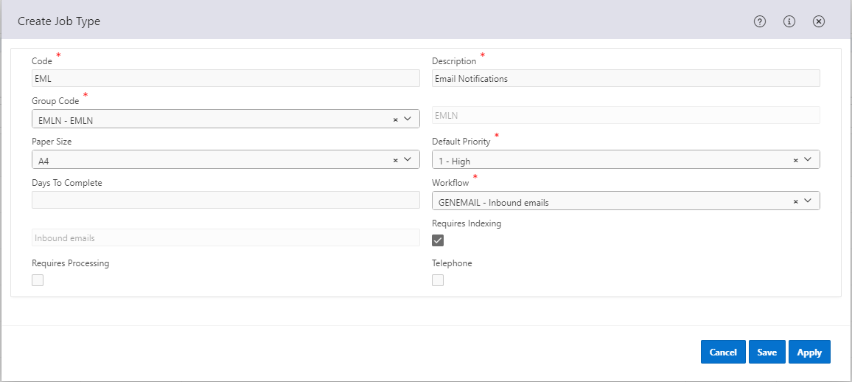
Select Job Types, and configure a new Job Type for each email inbox being monitored, see screen shot below for example. If required a different bespoke workflow can be created for each job type to provide different Summary Task descriptions. See 2.4.1 for details on how to do this.

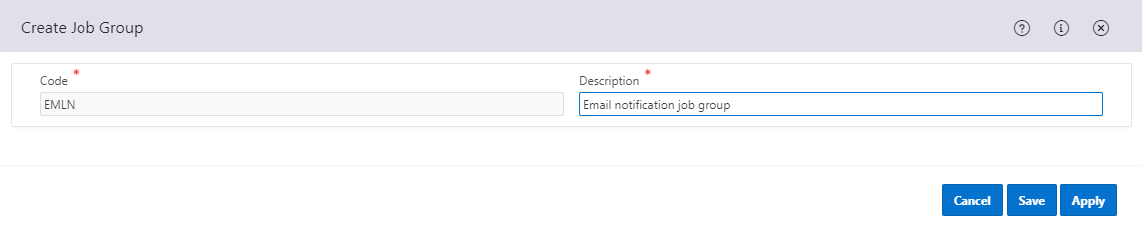
If desired, select Job Groups and configure an additional Job Group before creating the Job Types, as per following example screen shot:

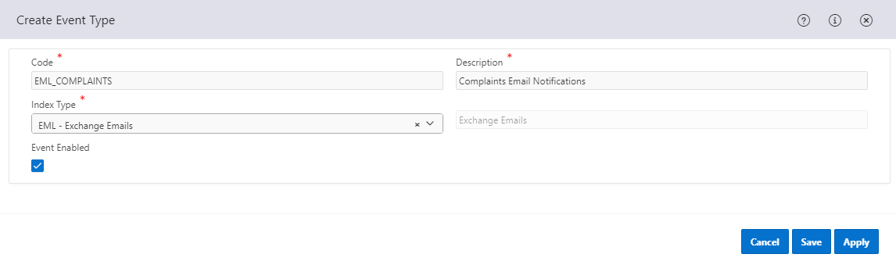
Select Event Types and configure a new Event Type for each Inbox being monitored, as per following example screen shot. These should be named ‘EML_’ with the relevant FRV value for the Inbox being appended to the Event Type Code, e.g. EML_ASB, EML_COMPLAINTS.

Assign the relevant Job Type to each new Event Query in the Child region.
Then go to System Setup › Task Manager › Task manager queries
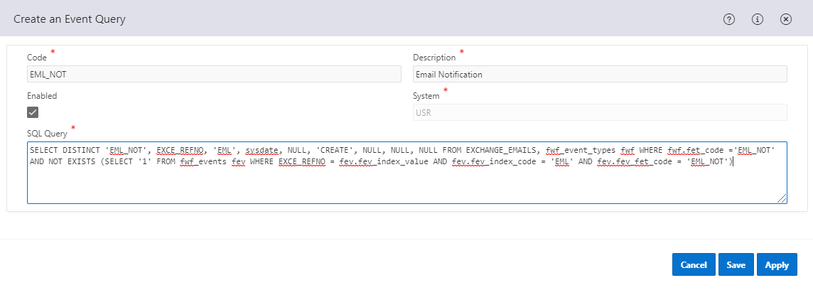
Select Event Queries, and configure a new event query, an example is shown below;

The Event Type codes and Event Queries can be configured as required within the Task Manager framework functionality.
The below SQL example will generate a TM Event for each new email previously unprocessed by Task Manager. It derives the Event Type code from the first part of the inbox email address appended to the constant ‘EML_’ in line with the configuration of the Event Types as described above.
SELECT DISTINCT 'EML_'||upper(substr(exce_email_to,1,instr(exce_email_to,'@')-1)),
EXCE_REFNO,
'EML',
sysdate,
NULL,
'CREATE',
NULL,
NULL,
NULL
FROM EXCHANGE_EMAILS, fwf_event_types fwf
WHERE fwf.fet_code ='EML_NOT'
AND NOT EXISTS (SELECT '1' FROM fwf_events fev
WHERE EXCE_REFNO = fev.fev_index_value
AND fev.fev_index_code = 'EML'
AND fev.fev_fet_code = 'EML_NOT')

2.2.5 Workflow File Creation
The Task Manager Summary page presents the user with a list of notifications, all grouped into specific Workflow categories. The list of Workflow categories is typically defined as system meta data, but it is possible for customers to extend this list themselves, using a simple find and replace on a pre-existing Workflow file.
Included with this document is an example workflow file called atcarep.wft, which you should open in your preferred text editor. Once open, you need to perform the following tasks:
ATCAREP - Replace with the name of the Workflow you want to use, maximum of 8 characters
Repair Authorisations - Replace with the name of the workflow eg Inbound Emails for ASB
Repair Authorisations Complete - Replace with the name of the workflow eg Inbound Emails for ASB Complete
Repair Authorisations Pending - Replace with the name of the workflow eg Inbound Emails for ASB Pending
Then save with a new name eg EMAILASB.wft
Then you need to upload to the server. There is a standard workflow upload script that is part of the installer. Your organisations NEC System Administrator or someone with similar privileges and knowledge will be able to do this.

2.2.6 Start Inbound Poll
The process and scripts to start the poll are tasks that should be carried out by your organisations NEC Database Administrator (DBA) or someone with similar privileges and knowledge.

2.3 Outbound Appointments
The integration between NEC Appointments and Outlook365 allows for appointments created and managed in NEC Housing to be integrated and loaded into a user’s Outlook 365 Calendar.
In addition to installing the OUTLOOK 365 licence and configuring the integration with Outlook 365 the following system parameter should be set to ‘Y’- APPTOUT_OUTLOOK365.
Parameter Name | APPTOUT_OUTLOOK365
Description | NEC to Outlook365 Calendar
Required | N
Datatype | Yes / No
Default Value
Hint | Enter Y to enable outbound appointments from NEC to Outlook365 Calendar

There is also a requirement to configure the OAUTH2 integration between NEC Housing and Outlook365 as per section 3 of this document. This configuration would typically be carried out by your organisations Azure Portal Administrator, in conjunction with your NEC Database Administrator.
Against each NEC Appointment Diary system administrators can configure whether a particular Diary will integrate with a user’s Outlook 365 Calendar.
To enable this configuration in System Setup →Estates → Appointments → Appointment Diaries. Either when creating a new Appointment Diary, or when Updating an existing Appointment Diary, in the relevant modal for the value of External Calendar, select Outlook 365 and in Calendar Address enter the email address for the users Outlook Calendar. This will validate the enter Calendar Address against the domain for your organisations Outlook 365 account in the System Parameter – INBOX_SERVER (the account domain name for your organisations Outlook 365 account – typically @housingorganisation.co.uk)

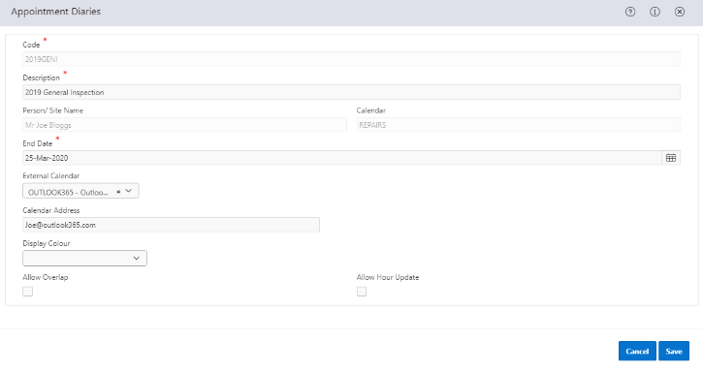
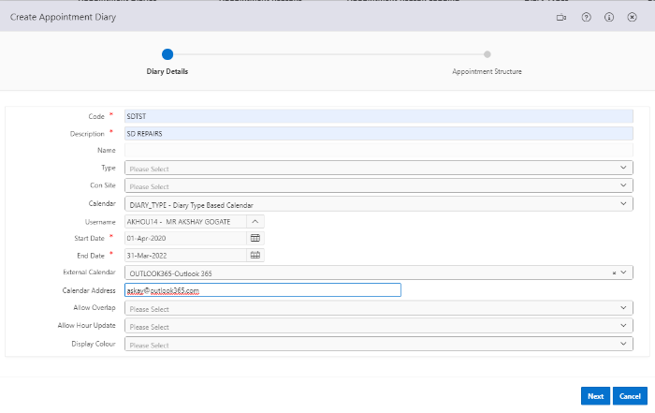
More than on NEC Appointment Diary can be related to a single instance of an Outlook 365 Calendar. So for example as a user I have two NEC Appointment Diaries (Rents Appointments and Estate Appointments), and only have one Outlook Calendar, so for each NEC Diary you would enter the same email address. Then when a new appointment booking is created for each NEC Diary this appointment would then also be created in the ‘mapped’ Outlook 365 calendar. The same would apply for move / update / cancellation of NEC Appointments.

2.4 Inbound Appointments
Outlook 365 integration allows Outlook Calendar users to move and cancels NEC Appointment bookings from their Outlook Calendar and changes to be updated in NEC Housing. NEC Housing will poll the Outlook 365 accounts associated with the Appointment Diaries, to pick up any changes to Appointments made from Outlook 365.
In addition to installing the OUTLOOK 365 licence and configuring the integration with Outlook 365 the following system parameter should be set to ‘Y’- APPTIN_OUTLOOK365.
Parameter Name | APPTIN_OUTLOOK365
Description | Outlook365 Calendar to NEC
Required | Y
Datatype | Yes / No
Default Value | N
Hint | Enter Y to enable inbound appointments from Outlook365 Calendar to NEC
There is also a requirement to configure the OAUTH2 integration between NEC Housing and Outlook365 as per section 3 of this document. This configuration would typically be carried out by your organisations Azure Portal Administrator, in conjunction with your NEC Database Administrator.
There are five system parameters used for this functionality:
- APPT_OUTLOOK365_CANCEL_RSN – sets the cancellation reason as defined in the parameter for the Appointment Booking
Parameter Name | APPT_OUTLOOK365_CANCEL_RSN
Description | Outlook365 Cancel Reason
Required | N
Datatype | Coded – (Appointment Reason Codes table)
Default Value
Hint | Enter the default reason why an Outlook365 calendar entry has been Cancelled
- APPT_OUTLOOK365_MOVE_RSN – sets the move reason as defined in the parameter for the Appointment Booking
Parameter Name | APPT_OUTLOOK365_MOVE_RSN
Description | Outlook365 Move Reason
Required | N
Datatype | Coded – (Appointment Reason Codes table)
Default Value
Hint | Enter the default reason why an Outlook365 calendar entry has been moved
- The lookup value in the above system parameters are populated from the Appointment Reasons configuration – Estates › Appointments › Appointment Reasons. The two reasons selected for the above parameters will need to be associated with all product areas in the in Appointment Reasons configuration
- OUTLOOK365_MOVE_VIOL_EMAIL – text value – maximum 255 characters, this will be used in an email to the Outlook Calendar owner to advise that appointment booking cannot be moved.
Parameter Name | OUTLOOK365_MOVE_VIOL_EMAIL
Description | Outlook365 Move viol
Required | N
Datatype | Text
Default Value
Hint | Enter the subject of email when an Outlook365 calendar entry has been moved
- CALI_POLL: This should be set to the number of minutes, in a numeric value, between each poll of Outlook 365 eg 10 – this will mean there will be 10 minutes elapsed time between each poll.
Parameter Name | CALI_POLL
Description | Outlook365 Calendar Poll minutes
Required | Y
Datatype | Numeric
Default Value | 1
Hint | Enter the number of minutes to poll from Outlook365 Calendar
• EMO_EMAILADDR needs to be populated with the outbound email address for your organisation.
Parameter Name | EMO_EMAILADDR
Description | From Email Address for messages
Required | N
Datatype | Text
Default Value | -
Hint | Enter from email address for sending external messages
All these parameters need to be configured to allow successful inbound integration with Outlook 365.

The following parameters are required for international (non UK timezone) customers only, and allow the database and Outlook365 to communicate in the correct timezone:
- OUTLOOK365_ORACLE_TIMEZONE: This parameter value needs to be updated to the returned value of the statement below and is case sensitive.
Parameter Name | OUTLOOK365_ORACLE_TIMEZONE
Description | Outlook365 Timezone
Required | N
Datatype | Text
Default Value | -
Hint | Enter the Timezone for the Oracle database calling Outlook
In addition your NEC Oracle Database Administrator should run the following:
select sessiontimezone from dual;

- OUTLOOK365_TIMEZONE: This parameter value needs to be updated to the appropriate timezone for your region and is case sensitive:
Parameter Name | OUTLOOK365_TIMEZONE
Description | Outlook365 Timezone
Required | N
Datatype | Text
Default Value
Hint | Enter the Timezone for the outlook calendar

A list of accepted time zones are as follows:
https://docs.microsoft.com/en-us/windows-hardware/manufacture/desktop/default-time-zones and
https://docs.microsoft.com/en-us/graph/api/resources/datetimetimezone?view=graph-rest-1.0#additional-time-zones

2.4.1 Cancelling Appointment
When Cancelling an NEC Appointment from their Outlook Calendar (Delete), this will cancel the appropriate appointment in NEC Housing – in effect taking the same action as though a NEC user had selected the appointment in Housing and used the action ‘Cancel Appointment’.
This will set the Appointment Booking Status to ‘CAN’ and populate the cancellation reason as per the value in the system parameter - APPT_OUTLOOK365_CANCEL_RSN.
Parameter Name | APPT_OUTLOOK365_CANCEL_RSN
Description | Outlook365 Cancel Reason
Required | N
Datatype | Coded – (Appointment Reason Codes table)
Default Value
Hint | Enter the default reason why an Outlook365 calendar entry has been Cancelled

2.4.2 Move Appointment
When Moving an NEC Appointment from their Outlook Calendar (Amend / Edit), this will move the appropriate appointment in NEC Housing, subject to the rules for the associated Appointment Diary – in effect taking the same action as though a NEC user had selected the appointment in Housing and used the action ‘Move Appointment’.
This will move the Appointment Booking and populate the move reason as per the value in the system parameter - APPT_OUTLOOK365_MOVE_RSN.
Parameter Name | APPT_OUTLOOK365_MOVE_RSN
Description | Outlook365 Move Reason
Required | N
Datatype | Coded – (Appointment Reason Codes table)
Default Value
Hint | Enter the default reason why an Outlook365 calendar entry has been moved

If when looking to Move an NEC Appointment Booking this request cannot be fulfilled then the Booking will not be moved, and the corresponding Outlook Calendar appointment will be reset to the original position. In addition the Outlook 365 Calendar owner, will be sent an email advising that the appointment cannot be moved, and include the text from the system parameter -OUTLOOK365_MOVE_VIOL_EMAIL. For example, the subject of this email will be the text in system parameter OUTLOOK365_MOVE_VIOL_EMAIL followed by the unique appointment reference. e.g.
Please review the following issue for the attempted move of the following appointment in your outlook calendar: : Appointment Ref 4376
The body of this email would be The ERROR text from the error that caused the move violation. This will describe the reason why the move was unsuccessful.
e.g. ‘No appointment slots exist for diary OR the appointment slots are in the past OR no units available in Appointment slots’

This notification email will be sent from the email account held in the system parameter - EMO_EMAILADDR.

2.4.3 Start Inbound Poll
The process and scripts to start the poll are tasks that should be carried out by your organisations NEC Database Administrator (DBA) or someone with similar privileges and knowledge.

3 Pluggable Authentication Modules (PAM) Configuration
Please see the separate technical guide for details of this configuration – ‘NEC Housing Outlook 365 Integration Technical Install’.

