

NEC Housing 21.1.0

Servicing User Guide

|  |  |
| --- | --- |
| |  | | --- | |  | |

Contents

Section 1: About this document 4

1.1 Related Documents 4

Section 2: Servicing Overview 5

Section 3: Service Contracts 6

3.1 Accessing the Contracts Summary Page 6

3.2 Contracts Summary Page 7

3.3 Contracts Advanced Search Form 8

3.4 Create Contract Wizard 10

3.5 Update Contract Form 14

3.6 Contract Details 16

3.7 Service Contract Addresses 18

3.8 Contract SORs 21

3.9 Contract Services 24

3.10 Errors 26

Section 4: Services 27

4.1 Accessing the Services Summary Page 27

4.2 Services Summary Page 28

4.3 Services Advanced Search Form 30

4.4 Service Details 35

4.5 Service Sections 37

4.6 Servicing Elements 38

4.7 Service Questions and Answers 40

4.8 Appointment Details 41

4.9 Service Works Orders 46

4.10 Attachments 47

4.11 Contacts 50

Section 5: Servicing Imports 52

5.1 Accessing the Imports Summary Page 52

5.2 Imports Summary Page 53

5.3 Import File Form 54

Section 6: Reports and Processes 55

6.1 Run Batch Jobs 55

6.2 Running Batch Jobs 55

6.3 Run Module Form 55

6.4 Generate Service Records Process 58

6.5 Module for Servicing Report (Generic) 59

6.6 Gas Safety Certificate for Landlords Report 59

6.7 EICR Certificate for Landlords Report 60

Section 1: About this document

This document is designed to give you the information that is needed to navigate around the NEC Housing module and assumes a level of familiarity with the system.

Each task that is available on the system will be explained separately. You can jump in anywhere; get the information you need and complete your work.

You can use this document to master tasks if you wish, or just keep it handy as a resource so that you can focus on other issues.

Further information is available in the online help which can be accessed by clicking the Help icon at the top of the region, form, or wizard that you want guidance on.



|  |
| --- |
| Tip:  For information about common user interface functions such as interactive reports, please refer to the Getting Started section within the online help which contains downloadable Quick Start guides. |

1.1 Related Documents

* NEC Housing Servicing System Administrator Guide

Section 2: Servicing Overview

The Servicing module specifically caters to cyclical servicing, which is a servicing task that happens frequently, sometimes due to legislation. For example, landlords are required to service their boiler installations on a yearly basis. As a result, by frequently servicing elements and components, you are helping to increase their lifespan.

You can create a contract which will allow you to select the properties and admin units, based on admin unit hierarchy, elements, etc., that require servicing. For example, to service all the boilers within the geographic area you specified. You can then create all the services for that contract, as necessary.

|  |
| --- |
| Tip:  If you have a list of the properties and admin units that your organisation manages on a device, you can load them from a spreadsheet and import them into the system. |

The next service date for a component or element is the very last date that it can be serviced. Therefore, the Servicing module allows you to specify a target date which will give the operatives time to access the properties and carry out the assessments, as well as allows the clients to reschedule the service for another date if they are no longer at home.

Once the first service task has been created, the next service task will be created from the data that was entered when creating the contract.

For gas and electrical assessments, the system will ship assessments to allow operatives to complete all the mandatory fields to create a certificate.

You will be able to use the appointments functionality in the system to manually schedule service appointments, allowing you to track and manage them.

If an operative is unable to access the property or admin unit, they will need to raise a no-access event. This will remove the service task from their schedule and send it back into the system, which will attempt to reschedule the appointment. If multiple attempts to access the property or admin unit fail, your organisation will have the ability to obtain the legal right to force access. This may involve many different parties, such as a housing officer, locksmith, etc.

If the operative can successfully enter the property or admin unit, they can carry out the inspection or works order as required by the service type. If the component or element needs to be replaced, the operative (providing that they have the correct job role) can raise a service request and record any defects that are present. As a result, a works order will be created which can be tracked in Servicing.

If required, operatives can replace the component or element if they decide that it has reach the end of its lifespan when they arrive at the property or admin unit. They will need to keep a record of the old component or element and the new one that they are replacing it with.

Section 3: Service Contracts

A contract is an agreement between your organisation and a contractor site to perform a specific task or complete a project. Each contract must be allocated to a contract type, which are pre-defined in system setup.

You will be able to select the properties that will exist in each contract based on admin unit hierarchy, property elements, etc. For example, if a contract is created to service the boilers in a geographic area, the properties/ admin units that possess these elements will be returned.

3.1 Accessing the Contracts Summary Page

To access the Contracts summary page, do the following:

1. Click Housing.



The Housing menu expands.

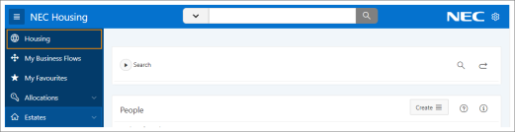

1. Click Servicing .



The Servicing menu expands.

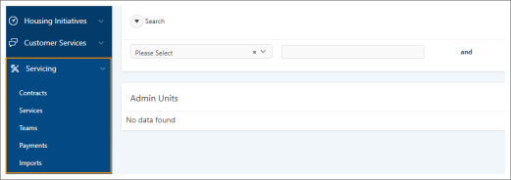

1. Click Contracts.

The Contracts summary page appears.

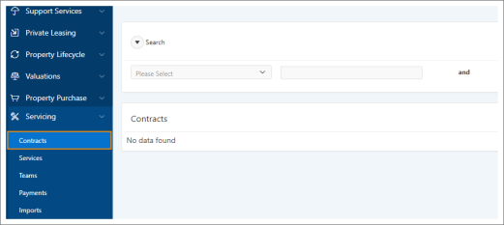

3.2 Contracts Summary Page

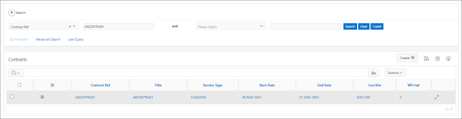

**Figure 1:** Example of the Contracts summary page

This summary page is divided into two sections:

Search

|  |
| --- |
| To display records, you need to enter your search criteria in the Quick Search area at the top of the page and click the Search button.  If the Quick Search options do not meet your needs, click the Advanced Search icon to access the advanced search form and enter more specific criteria. |

Contracts Region

This region displays the contracts that meet your search criteria and enables you to:

* Access the Contracts Details page

Select Contract Details from the Row Action list corresponding to the record you want to maintain the details of.



See 3.6.2 Contract Details Page on page 18 for more information.

* Create a contract

Select Create Contract from the Create list at the top of the region and enter the new details in the Create Contract wizard.



See 3.4 Create Contract Wizard on page 11 for details.

* Delete a contract

Select Delete Contract from the Row Action list corresponding to the record you want to delete and confirm the deletion when prompted.



* Review GPI job output

Select Review GPI Job Output from the Create list at the top of the region to access the Review GPI Job Output summary page where you can view details of the scheduled jobs output.



* Update a contract

Select Update Contract from the Row Action list corresponding to the record you want to update and make the necessary changes in the Update Contract form.



See 3.5 Update Contract Form on page 15 for details.

3.3 Contracts Advanced Search Form

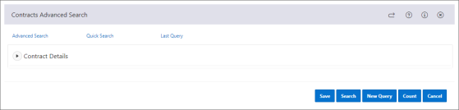

**Figure 2:** Example of the Contracts Advanced Search form

This form contains the following area, providing further search criteria relevant to that area.

Contract Details

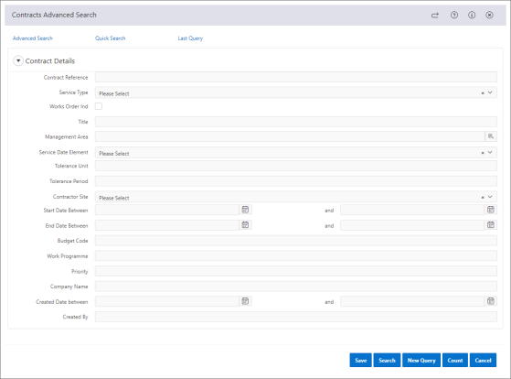

**Figure 3:** Example of the Contracts Details search area

* Contract Reference

Enter the reference of the contract you are looking for.

* Service Type

Select the service type associated with the contract you are looking for.

* Works Order Ind

Check this box to include contracts with works orders in your search results.

|  |
| --- |
| Tip:  If this box is left unchecked, no records will be returned despite the other search criteria you have specified. |

* Title

Enter the title of the contract you are looking for.

* Management area

Select the management area associated with the contract you are looking for.

* Service Date Element

Select the service date element associated with the contract you are looking for.

* Tolerance Unit

Enter the tolerance unit associated with the contract you are looking for.

* Tolerance Period

Enter the tolerance period associated with the contract you are looking for.

* Contractor Site

Enter the name of the contractor site associated with the contract you are looking for.

* Start Date Between

Enter the earliest start date of the contract you are looking for.

* and

Enter the latest start date of the contract you are looking for.

* End Date Between

Enter the earliest end date of the contract you are looking for.

* and

Enter the latest end date of the contract you are looking for.

* Budget Code

Enter the budget code associated with the contract you are looking for.

* Work Programme

Enter the work programme associated with the contract you are looking for.

* Priority

Enter the priority number associated with the contract you are looking for.

* Company Name

Enter the company name associated with the contract you are looking for.

* Created Date between

Enter the earliest date the contract you are looking for was created.

* and

Enter the latest date the contract you are looking for was created.

* Created By

Enter the name of the user who created the contract you are looking for.

3.4 Create Contract Wizard

This wizard consists of the following pages:

3.4.1 Contract Details

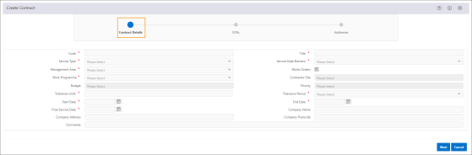

**Figure 4:** Example of the Create Contracts wizard Contracts Details page

Use this page to record the details of the contract.

This page contains the following fields:

* Code *

Enter a unique code for the contract.

* Title *

Enter the title of the contract.

* Service Type *

Select the type of service the contract is for.

* Service Date Element *

Select the property element that will be used to define the service date.

|  |
| --- |
| Important:  This date will be used by GPI to work our when the next service is due. |

* Management Area *

Select the management area that the contract will encompass.

* Works Orders

By default this box is checked, indicating that works orders will be created for the services included in this contract.

* Work Programme *

Select the work programme to be associated with the contract.

* Contractor Site *

Select the contractor site that will be responsible for the contract.

|  |
| --- |
| Note:  This field is only accessible when a management area and work programme has been selected. |

* Budget *

Select the budget head code for the contract.

|  |
| --- |
| Note:  This field is only accessible when a management area has been selected. |

* Priority *

Select the priority code of the work programme associated with the contract.

|  |
| --- |
| Note:  This field is only accessible when a work programme has been selected. |

* Tolerance Units *

Enter a number to determine the tolerance surrounding the final date that the service is to be carried out.

|  |
| --- |
| Example:  If the tolerance unit is 2 and the tolerance period selected is months, the system will generate your service record 2 months earlier than the service date using the HSE-GEN-SER GPI process. This allows you to schedule and book appointments with the aim to have them completed before the final deadline. |

|  |
| --- |
| Tip:  This must be a positive integer between 1 and 999, inclusive. It is used in conjunction with the Tolerance Period field, for example, 4 weeks. |

* Tolerance Period *

Select the period that will be used to measure the tolerance unit:

* + Days
  + Months
  + Weeks
* Start Date *

Enter the start date of the contract.

* End Date *

Enter the end date of the contract.

* Final Service Date *

Enter the final possible date that the service specified in the contract can be carried out.

* Company Name

Enter the contractor's company name.

* Company Address

Enter the contractor's company address

* Company Postcode

Enter the contractor's company postcode.

* Calendar

Select the calendar that is used to informed the contract of which budget year to pick when payments are created.

|  |
| --- |
| Tip:  This field is only accessible if the Work Orders box is unchecked. |

* Comments

Enter any additional information about the contract.

3.4.2 SORs

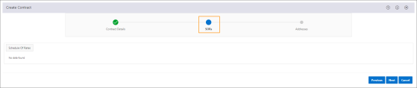

**Figure 5:** Example of the Create Contracts wizard SORs page

Use this page to record the schedule of rate (SOR) items that should be associated with the contract.

This page contains the following fields:

* Schedule Of Rates

Click this button to search for and select the schedule of rate items you want to add to the contract.

|  |
| --- |
| Important:  At least one schedule of rate item must be flagged as a service code before you can proceed to the next page. |

* Code

The schedule of rates code.

* Description

The schedule of rates description

* Service

Select Yes to indicate that this will be created against the service as the default code. If otherwise, select No.

|  |
| --- |
| Tip:  More than one code can be set to Yes. |

* Repeat Per Element

Check this box to indicate that schedule of rate (SOR) codes should be repeated on a service based on the number of elements that are assigned against the property or admin unit.

3.4.3 Addresses

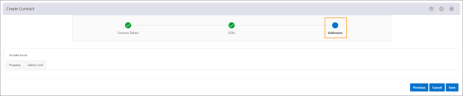

**Figure 6:** Example of the Create Contracts wizard Addresses page

Use this page to record details of the addresses that will be assigned to the contract.

This page contains the following fields:

* Property

Click this button to search for and select the property you want to add to the contract.

* Admin Unit

Click this button to search for and select the admin unit you want to add to the contract.

* Prop/ Au

The property reference/ admin unit code.

* P/ A

Indicates whether the address is for a:

* + P - Property
  + A - Admin unit
* Address

The address of the property/ admin unit.

3.5 Update Contract Form

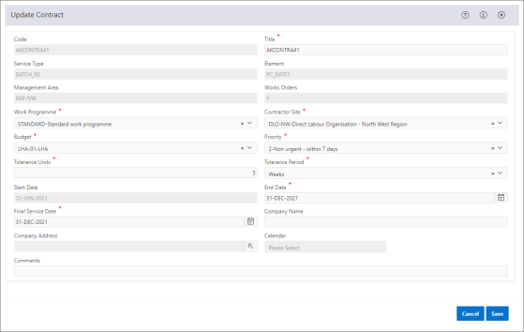

**Figure 7:** Example of the Update Contract form

This form contains the following fields:

* Code

The code for the contract.

* Title *

Enter the title of the contract.

* Service Type

The type of service the contract is for.

* Service Date Element

The property element that is used to define the service date.

|  |
| --- |
| Important:  This date will be used by GPI to work our when the next service is due. |

* Management Area

The management area that the contract will encompass.

* Works Orders

When set to Y, works orders will be created for the services included in this contract.

* Work Programme *

Select the work programme to be associated with the contract.

* Contractor Site *

Select the contractor site that will be responsible for the contract.

|  |
| --- |
| Note:  This field is only accessible when a management area and work programme has been selected. |

* Budget *

Select the budget head code for the contract.

|  |
| --- |
| Note:  This field is only accessible when a management area has been selected. |

* Priority *

Select the priority code of the work programme associated with the contract.

|  |
| --- |
| Note:  This field is only accessible when a work programme has been selected. |

* Tolerance Units *

Enter a number to determine the tolerance surrounding the final date that the service is to be carried out.

|  |
| --- |
| Example:  If the tolerance unit is 2 and the tolerance period selected is months, the system will generate your service record 2 months earlier than the service date. This allows you to schedule and book appointments with the aim to have them completed before the final deadline. |

|  |
| --- |
| Tip:  This must be a positive integer between 1 and 999, inclusive. It is used in conjunction with the Tolerance Period field, for example, 4 weeks. |

* Tolerance Period *

Select the period that will be used to measure the tolerance unit:

* + Days
  + Months
  + Weeks
* Start Date *

Enter the start date of the contract.

|  |
| --- |
| Tip:  If the start date is less than the current system date, this field will be read-only and cannot be updated. |

* End Date *

Enter the end date of the contract.

* Final Service Date *

Enter the final possible date that the service specified in the contract can be carried out.

* Company Name

Enter the contractor's company name.

* Company Address

Enter the contractor's company address

* Company Postcode

Enter the contractor's company postcode.

* Comments

Enter any additional information about the contract.

3.6 Contract Details

Once a contract has been created you can view and/or maintain the information associated with it such as:

* Contract Schedule of Rates (SORs)
* Contract Addresses
* Contract Services
* Errors

This is done from the Contract Details page.

3.6.1 Accessing the Contract Details Page

To access the Contracts details page, perform the following steps:

1. Navigate to the Contracts summary page.

For further information, see "Accessing the Contracts Summary Page" on page 7.

1. Enter your search criteria in the Search area.

If the Quick Search options do not meet your needs, click the Advanced Search icon at the top of the Search area, and enter more specific criteria.



1. Click Search.

The records that meet your search criteria appear in the Contracts region.

1. Do one of the following:
   * To select multiple records simultaneously, check the boxes corresponding to the records you require, then select Contract Details from the Bulk Actions list in the table heading.



* + To select a single record, select Contract Details from the corresponding Row Action list .



The Contract Details page appears.

3.6.2 Contract Details Page

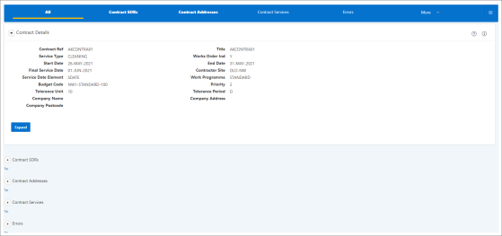

**Figure 8:** Example of the Contracts Details Page

The Contract Details page provides further information about the selected contract.

Whilst you can select several records simultaneously from the Contracts region, you will only be able to view and maintain them here one at a time.

The information displayed in the 'context block' at the top of the page is specific to the record currently selected. If you selected multiple records on the summary page you can scroll through them here using the Next and Previous buttons at the bottom of the context block.

Context Block Fields

| Field | Description |
| --- | --- |
| Contract. Ref | The reference of the selected contract. |
| Title | The title of the contract. |
| Service Type | The service type associated with the contract. |
| Works Order Ind | When set to Y, works orders have been attached to this contract. |
| Start Date | The start date of the contract. |
| End Date | The date the contract ends. |
| Final Service Date | The final date that the HSE-GEN-SER GPI job will run to create services for the contract. |
| Contractor Site | The contractor site associated with the contract. |
| Service Date Element | The service element date. |
| Priority | The number that determines the priority of the contract. |
| Tolerance Unit | The number that determines the tolerance surrounding the date that the service is to be carried out. |
| Tolerance Period | Indicates the period that will be used to measure the tolerance unit:   * Days * Months * Weeks |
| Company Name | The name of the company. |
| Company Address | The address of the company. |
| Company Postcode | The company postcode. |

3.6.2.1 How to Maintain Records

To maintain the currently selected record, use the options at the top of the page to access the appropriate region where you can carry out the necessary action.

Alternatively, use the Actions or Links available in the Options pane on the right-hand side of the page.

|  |
| --- |
| Tip:  Click the Actions icon to hide or display the list of actions and links available in a pop-up window. |

3.7 Service Contract Addresses

Contract addresses are the list of addresses at which the work that has been specified in the contract is to be undertaken. You can add and remove addresses from a contract using the Contract Addresses region.

3.7.1 Accessing the Contract Addresses Region

To access the Contract Addresses region, perform the following steps:

1. Navigate to the Contract Details page.

For further information, see "Accessing the Contract Details Page" on page 17.

1. Click Contract Addresses at the top of the page.

|  |
| --- |
| Tip:  If this link is not visible at the top of the screen, click More to expand the menu. |

The page refreshes to display the selected region.

You can now view the contract addresses relevant to the contract in context.

3.7.2 Contract Addresses Region

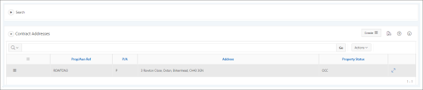

**Figure 9:** Example of the Contract Addresses region

This region displays the current addresses relevant to the contract in context and enables you to:

* Create a contract address

Select Create Contract Address from the Create list at the top of the region and enter the new details in the Create Contract Address form.



* Create a service

Select Create Service from the Row Action list corresponding to the contract address you want to create a service for and click Save.



|  |
| --- |
| Note:  You can only perform this action against a property or admin unit that does not have an existing service with a status equal to COM or CAN, and if the property or admin unit does not have any existing works orders errors for the contract they are associated with. |

* Delete a contract address

Select Delete Contract Address from the Row Action list corresponding to the record you want to delete and confirm the deletion when prompted.



* Import a file

Select Import Files from the Create list at the top of the region and enter the relevant data in the Import File form.



You can also:

* Filter the records displayed
  + Click the Search area Open icon above the region and enter your search criteria.



* + Use the Search Report at the top of the region.
* View and maintain any associations with the selected record

Click the corresponding Select this record icon to access the following regions:



* + Contract Services
  + General Inspections

3.7.3 Create Contract Address Form

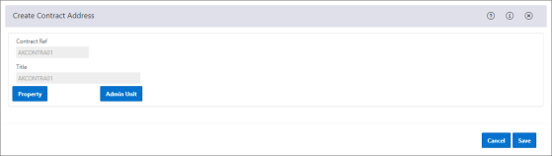

**Figure 10:** Example of the Create Contract Address form

This form contains the following fields:

* Contract Ref

The contract reference.

* Title

The title of the contract.

* Property

Click this button to search for the property you want to add to the contract.

* Admin Unit

Click this button to search for the admin unit you want to add to the contract.

* Prop/ Au Ref

The property reference/ admin unit code.

* P/ A

Indicates whether the reference/ code refers to a:

* + A - Admin Unit
  + P - Property
* Address

The address of the property/ admin unit.

3.7.4 Import File Form

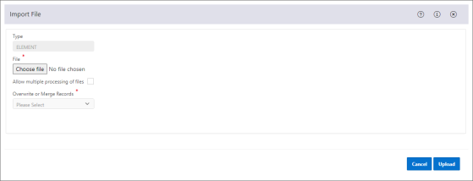

**Figure 11:** Example of the Import File form

This form contains the following fields:

* Type *

Select the type of file that you want to import.

|  |
| --- |
| Note:  For Servicing, when accessed from the Imports summary page, this will default to ELEMENT. However, if accessed from the Contract Addresses region, it defaults to ADDRESS. |

* File *

Click the Choose file button to search for and select the file you want to import.

* Allow multiple processing of files

When this field is not checked a named file previously loaded cannot be loaded again.

When checked, this allows a named file previously loaded to be loaded subsequently in the case for example of purposefully reloading corrected data sets.

* Overwrite or Merge Records *

Select an option to specify whether or not the records associated with this file should be overwritten or merged when imported into NEC Housing.

|  |
| --- |
| Note:  This is only applicable to Asset Management. |

3.8 Contract SORs

Contract schedule of rates (SORs) are useful as they allow you to select multiple SORs at a time, based on a contract type, and assign them to a contract. These schedules of rates define the deliverables and deliverable components for the contract.

You can do this from the Contract SORs region.

3.8.1 Accessing the Contract SOR Region

To access the Contract SORs region, perform the following steps:

1. Navigate to the Contract Details page.

For further information, see "Accessing the Contract Details Page" on page 17.

1. Click the Contract SORs link at the top of the screen.

|  |
| --- |
| Tip:  If this link is not visible at the top of the screen, click More to expand the menu. |

The page refreshes to display the selected region.

You can now view and maintain the schedule of rates (SORs) relevant to the contract in context.

3.8.2 Contract SORs Region

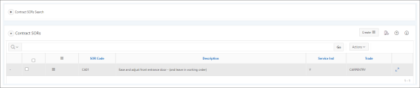

**Figure 12:** Example of the Contract SORs region

This region displays the current schedule of rates (SORs) relevant to the contract in context and enables you to:

* Create a contract SOR

Select Create Contract SOR from the Create list at the top of the region and enter the new details in the Create Contract SOR form.



* Delete a contract SOR

Select Delete Contract SOR from the Row Action list corresponding to the record you want to delete and confirm the deletion when prompted.



* Update a contract SOR

Select Update Contract SOR from the Row Action list corresponding to the record you want to update and make the necessary changes in the Update Contract SORs form.



* Update contract SORs in bulk

Check the boxes in the corresponding rows and select Update Contract SOR from the Bulk Actions list in the table heading and make the necessary changes in the Update Contract SORs form.



You can also:

* Filter the records displayed
  + Click the Contract SORs Search area Open icon above the region and enter your search criteria.



* + Use the Search Report at the top of the region.

3.8.3 Create Contract SORs Form

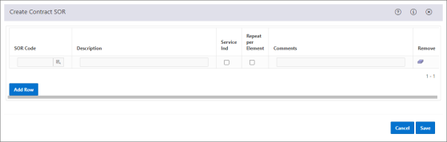

**Figure 13:** Example of the Create Contract SORs region

This form contains the following fields:

* SOR Code

Enter the code of the schedule of rate (SOR) you want to add to the contract.

* Description

The description of the schedule of rate (SOR).

* Service Ind

Check this box to indicate that this schedule of rate (SOR) is required as part of the service. If it only needs to be checked by an operative, leave unchecked.

* Repeat Per Element

Check this box to indicate that schedule of rate (SOR) codes should be repeated on a service based on the number of elements that are assigned against the property or admin unit.

* Comments

Enter any additional information about the schedule of rate (SOR).

3.8.4 Update Contract SORs Form

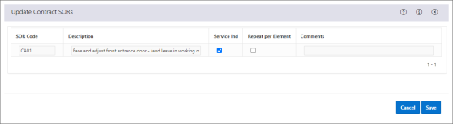

**Figure 14:** Example of the Create Contract SORs region

This form contains the following fields:

* SOR Code

The code of the schedule of rate (SOR) assigned to the contract.

* Description

The description of the schedule of rate (SOR).

* Service Ind

Check this box to indicate that this schedule of rate (SOR) is required as part of the service. If it only needs to be checked by an operative, leave unchecked.

* Repeat Per Element

Check this box to indicate that schedule of rate (SOR) codes should be repeated on a service based on the number of elements that are assigned against the property or admin unit.

* Comments

Enter any additional information about the schedule of rate (SOR).

3.9 Contract Services

The Contract Services region displays a list of all the services that have been raised for the contract in context. This is useful for information and management purposes.

3.9.1 Accessing the Contract Services Region

To access the Contract Services region, perform the following steps:

1. Navigate to the Contract Details page.

For further information, see "Accessing the Contract Details Page" on page 17.

1. Click the Contract Services link at the top of the screen.

|  |
| --- |
| Tip:  If this link is not visible at the top of the screen, click More to expand the menu. |

The page refreshes to display the selected region.

You can now view the details of the services relevant to the contract in context.

3.9.2 Contract Services Region

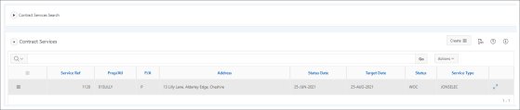

**Figure 15:** Example of the Contract Services region

This region displays the current services relevant to the contract in context and enables you to:

* Access the Services Details page

Select Services Details from the Row Action list corresponding to the record you want to maintain.



* Complete a service

Select Complete Service from the Row Action list corresponding to the record you want to complete and enter the relevant data in the Complete Service form.



|  |
| --- |
| Note:  You can only perform this action if the service selected has a status of WOC or RAI and all the mandatory questions associated with it have been answered. |

You can also:

* Filter the records displayed
  + Click the Contract Services Search area Open icon above the region and enter your search criteria.



* + Use the Search Report at the top of the region.

3.10 Errors

The Errors region displays the errors that were generated when attempting to create a works order for a service.

3.10.1 Accessing the Errors Region

To access the Errors region, perform the following steps:

1. Navigate to the Contract Details page.

For further information, see "Accessing the Contract Details Page" on page 17.

1. Click Errors at the top of the page.

|  |
| --- |
| Tip:  If this link is not visible at the top of the screen, click More to expand the menu. |

The page refreshes to display the selected region.

You can now ever the error details relevant to the contract in context.

3.10.2 Errors Region

This region displays the works order errors and enables you to filter the records displayed using the Search Report at the top of the region.

Section 4: Services

A service is a routine task, such as maintenance or repair work, that is required as part of the contractual agreement your organisation has entered into with your customers.

4.1 Accessing the Services Summary Page

To access the Services summary page, do the following:

1. Click Housing.



The Housing menu expands.



1. Click Servicing .



The Servicing menu expands.



1. Click Services.

The Services summary page appears.

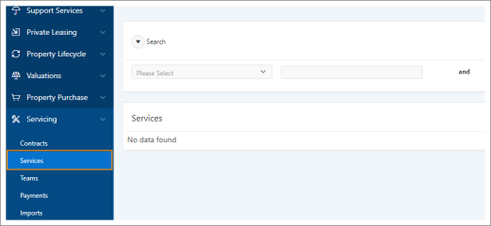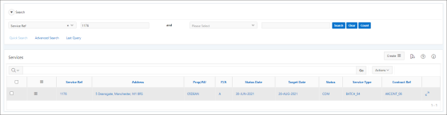

**Figure 16:** Example of the Services summary page

4.2 Services Summary Page

This summary page is divided into two sections:

Search

|  |
| --- |
| To display records, you need to enter your search criteria in the Quick Search area at the top of the page and click the Search button.  If the Quick Search options do not meet your needs, click the Advanced Search icon to access the advanced search form and enter more specific criteria. |

Services Region

This region displays the services that meet your search criteria and enables you to:

* Access the Services Details page

Select Services Details from the Row Action list corresponding to the record you want to maintain the details of.



See 4.4.2 Services Details Page on page 37 for more information.

* Cancel a service

Select Cancel Service from the Row Action list corresponding to the record you want to cancel and confirm the action when prompted.



|  |
| --- |
| Note:  You can only complete this task if the service selected has a status of RAI (raised). |

* Complete a service

Select Complete Service from the Row Action list corresponding to the record you want to complete and enter the relevant data in the Complete Service form.



Tell me how

|  |
| --- |
| Note:  You can only complete this task if the service selected has a status of WOC or RAI and all the mandatory questions associated with it have been answered. |

* Review GPI job output

Select Review GPI Job Output from the Create list at the top of the region to access the Review GPI Job Output summary page where you can view details of the scheduled jobs output.



* Run a context report

Select Context Reports from the Row Action list corresponding to the record you want to run a context report for.



* Update a service

Select Update Service from the Row Action list corresponding to the record you want to update and enter the relevant data in the Update Service form.



Tell me how

|  |
| --- |
| Note:  You can only complete this task if the service selected has a status of or RAI (raised). |

4.3 Services Advanced Search Form

This form contains the following areas, each providing further search criteria relevant to that area.

Services Details

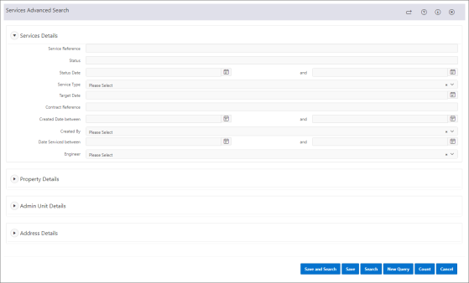

**Figure 17:** Example of the Services Details area in the Services Advanced Search

Use this area to find services by their known details.

This area contains the following fields:

* Service Reference

Enter the reference of the service you are looking for.

* Status

Enter the current status of the service you are looking for.

* Status Date

Enter the earliest date the service you are looking for attained it's current status.

* and

Enter the latest date the service you are looking for attained it's current status.

* Service Type

Select the type of service you are looking for.

* Target Date

Enter the target date of the service you are looking for.

* Contract Reference

Enter the contract reference associated with the service you are looking for.

* Create Date between

Enter the earliest date the service you are looking for was created.

* and

Enter the latest date the service you are looking for was created.

* Created By

Select the name of the person who created the service you are looking for.

* Engineer

Select the name of the engineer who performed the service you are looking for.

4.3.1 Property Details

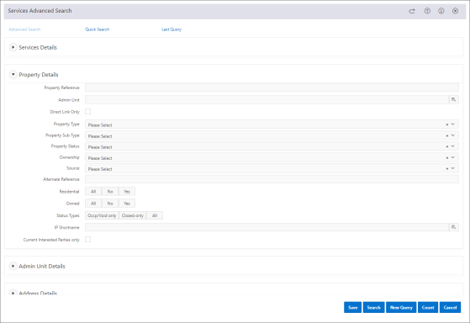

**Figure 18:** Example of the Property Details area in the Services Advanced Search

Use this area to enter the property details you want to use to find service.

This area contains the following fields:

* Property Reference

Enter the reference for the property you are looking for.

* Admin Unit

Enter the admin unit code associated with the property you are looking for.

* Direct Link Only

Check this box to restrict search results to records that are directly assigned to the property you are looking for.

* Property Type

Select the property type you are looking for.

* Property Sub type

Select the property sub type you are looking for.

* Property Status

Select the property status you are looking for.

* Ownership

Select the ownership type of the property you are looking for.

* Source

Select the property source you are looking for.

* Alternate Reference

Enter the alternate reference for the property you are looking for.

* Residential

Select one of the following:

* + Yes - to return current records.
  + No - to return records that are no longer current.
  + All - to return all records regardless of status.
* Owned

Select one of the following:

* + Yes - to return current records.
  + No - to return records that are no longer current.
  + All - to return all records regardless of status.
* Status Type

Select one of the following:

* + Occp/ Void only - to return only records with a status type of occupied or void.
  + Closed only - to return only records with a status type of closed.
  + All - to return all records regardless of status.
* IP Shortname

Enter the shortname of the interested party you are looking for.

* Current Interested Parties Only

Check this box to restrict search results to current interested parties only.

4.3.2 Admin Unit Details

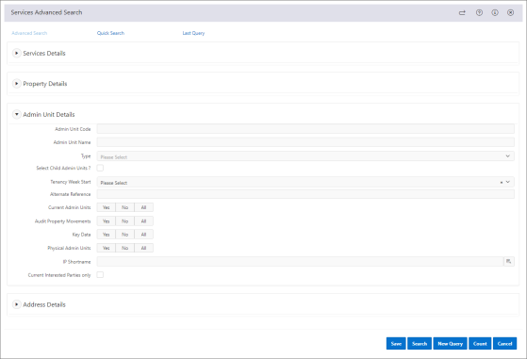

**Figure 19:** Example of the Admin Unit Details area in the Services Advanced Search

Use this area to enter the admin unit details you want to use to find service.

This area contains the following fields:

* Admin Unit Code

Enter the admin unit code you are looking for.

* Admin Unit Name

Enter the name of the admin unit you are looking for.

* Type

Select the admin unit type you are looking for.

* Select Child Admin Units?

Check this box to include admin units with child admin units in the search result.

* Tenancy Week Start

Select the day of the week on which the tenancy associated with the admin unit you are looking for starts.

* Alternate Reference

Enter the alternative reference of the admin unit you are looking for.

* Current Admin Units

Select an option to specify the status of the admin unit:

* + Yes - Restrict search results to admin units that are current.
  + No - Restrict search results to admin units that are no longer current.
  + All - Display all admin units that meet your search criteria regardless of whether they are current or not.
* Audit Property Movements

Select an option to specify the status of the audit property movements you are looking for:

* + All - Display all audit property movements that meet your search criteria regardless of whether they are current or not.
  + No - Restrict search results to audit property movements that are no longer current.
  + Yes - Restrict search results to audit property movements that are current.
* Key Data

Select an option to specify the status of the key data you are looking for.

* + All - Display all key data that meet your search criteria regardless of whether it is current or not.
  + No - Restrict search results to key data that is no longer current.
  + Yes - Restrict search results to key data that is current.
* Physical Admin Unit

Select an option to specify the status of the physical admin unit.

* + Yes - Restrict search results to physical admin units that are current.
  + No - Restrict search results to physical admin units that are no longer current.
  + All - Display all physical admin units regardless of whether they are current or not.
* Interested Party Shortname

Enter the shortname of the interested party you are looking for.

* Current Interested Parties Only

Check this box to restrict search results to current interested parties only.

4.3.3 Address Details

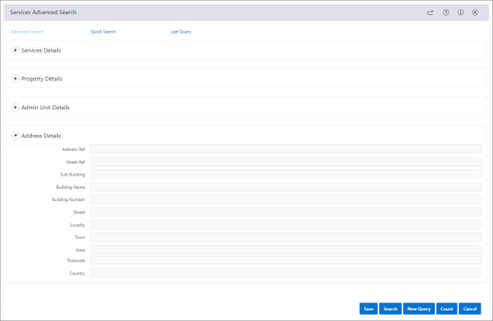

**Figure 20:** Example of the Address Details area in the Services Advanced Search

Use this area to enter the parts of the address you want to use to find a record.

4.4 Service Details

Once a service has been created you can view and/or maintain the information associated with it such as:

* Sections
* Works Orders
* Attachments

This is done from the Service Details page.

4.4.1 Accessing the Services Details Page

To access the Services Details page, perform the following steps:

1. Navigate to the Services summary page.

For further information, see "Accessing the Services Summary Page" on page 28.

1. Enter your search criteria in the Search area.

If the Quick Search options do not meet your needs, click the Advanced Search icon at the top of the Search area, and enter more specific criteria.



1. Click Search.

The records that meet your search criteria appear in the Services region.

1. Do one of the following:
   * To select multiple records simultaneously, check the boxes corresponding to the records you require, then select Services Details from the Bulk Actions list in the table heading.



* + To select a single record, select Services Details from the corresponding Row Action list .



The Services Details page appears.

4.4.2 Services Details Page

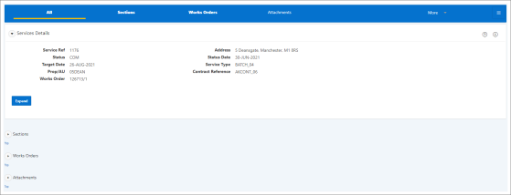

**Figure 21:** Example of the Service Details Page

The Services Details page provides further information about the selected service.

Whilst you can select several records simultaneously from the Services region, you will only be able to view and maintain them here one at a time.

The information displayed in the 'context block' at the top of the page is specific to the record currently selected. If you selected multiple records on the summary page you can scroll through them here using the Next and Previous buttons at the bottom of the context block.

Context Block Fields

| Field | Description |
| --- | --- |
| Service Ref | The reference of the selected service. |
| Address | The address of the property/ admin unit the service is due to be carried out. |
| Status | The current status of the service. |
| Status Date | The date on which the service attained its current status. |
| Prop/ Au | The property reference/ admin unit code. |
| Contract Reference | The contract reference that the service is assigned to. |
| Works Order | The works order that has been raised as a result of the service creation. |

4.4.2.1 How to Maintain Records

To maintain the currently selected record, use the options at the top of the page to access the appropriate region where you can carry out the necessary action.

Alternatively, use the Actions or Links available in the Options pane on the right-hand side of the page.

|  |
| --- |
| Tip:  Click the Actions icon to hide or display the list of actions and links available in a pop-up window. |

4.5 Service Sections

During a service, various questions will need to be asked and answered. These will differ from location to location as well as from service to service.

To ensure that the questions asked are both pertinent and relevant to the service being undertaken, they are grouped together in accordance with the sections included in that service. For example, any questions relating to the boiler could be grouped within a section called 'Heating'.

Each section will contain a number of questions which will either be used for the purpose of gathering information or ascertaining whether the element/ component being serviced needs to be replaced.

You can view the sections included in a service and maintain the responses to the questions associated with each from the Sections region.

4.5.1 Accessing the Sections Region

To access the Sections region, perform the following steps:

1. Navigate to the Services Details page.

For further information, see "Accessing the Services Details Page" on page 36.

1. Click the Sections link at the top of the screen.

|  |
| --- |
| Tip:  If this link is not visible at the top of the screen, click More to expand the menu. |

The page refreshes to display the selected region.

You can now view and maintain details of the sections relevant to the service in context.

4.5.2 Sections Region

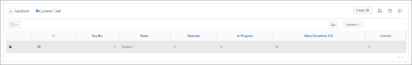

**Figure 22:** Example of the Sections region

This region displays the current sections relevant to the service in context and enables you to:

* Filter the records displayed
  + Use the Current or All buttons at the top of the region.
  + Use the Search Report at the top of the region.
* View and maintain any associations with the selected record

Click the corresponding Select this record icon to access the following regions:



* + Elements

|  |
| --- |
| Note:  This region is only displayed if the Elements indicator for the selected section is set to Y (yes). |

* + View Questions and Answers

|  |
| --- |
| Note:  This region is only displayed if the Elements indicator for the selected section is set to N (no). |

4.6 Servicing Elements

These are the individual elements that will be inspected, maintained or repaired as part of the service agreement.

4.6.1 Accessing the Elements Region

|  |
| --- |
| Note:  You can only complete this task if the Elements indicator in the Sections region is set to Y (yes). If set to N, the View Questions and Answers region will be visible instead. |

To access the Elements region, perform the following steps:

1. Navigate to the Sections region.

For further information, see "Accessing the Sections Region" on page 38.

1. Click the Select this record icon in the row corresponding to the record you want to select.



The Elements option appears below the Sections region.

1. Click the Elements option Open icon.



The Elements region opens.

You can now view the elements for the section in context.

4.6.2 Elements Region

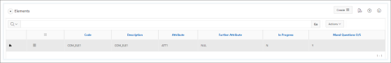

**Figure 23:** Example of the Elements region

This region displays the current elements relevant to the section in context and enables you to:

* Maintain Section Responses

Select Maintain Section Responses from the Row Action list corresponding to the record you want to update and make the necessary changes in the Maintain Section Responses form.



You can also:

* Filter the records displayed

Use the Search Report at the top of the region.

* View the questions and answers associated with the selected record

Click the Select this record icon to access the View Question and Answers region.



4.6.3 Maintain Section Element Responses Form

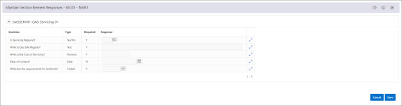

**Figure 24:** Example of the Maintain Section Element Responses form

This form contains the following fields:

* Question

The question for the service section.

* Type

The data type of the question:

* + Coded
  + Date
  + Numeric
  + Text
  + Yes/No
* Required

When set to Y, a response is required for this question.

* Response

Enter or select an appropriate response to the question.

|  |
| --- |
| Note:  If the data type of the question is Date, you can click the Calendar icon to select a date.  If the data type is Coded, you can click the Select List icon to select a value. |

* Additional Response

Enter an additional response to the question.

|  |
| --- |
| Note:  Click the Expand icon at the end of the corresponding row to access this field. |

4.7 Service Questions and Answers

An operative that is sent out to a customer site may be required to answer a series of questions during their inspection of the element or component that is listed in the service requirement. The View Question and Answers region allows you to view the questions that were asked and the responses that the operative responded with.

|  |
| --- |
| Important:  The questions linked to a section are unique for that sections and cannot be added to multiple sections. |

4.7.1 Accessing the View Questions and Answers Region

To access the View Questions and Answers region, perform the following steps:

1. Navigate to the Sections region.

For further information, see "Accessing the Sections Region" on page 39.

1. Click the Select this record icon in the row corresponding to the record you want to select.



The Elements option appears below the Sections region.

|  |
| --- |
| Note:  If the Elements indicator in the Sections region is set to N (no), clicking the Select this record icon will display the View Questions and Answers region instead of the Elements region. |

1. Click the Elements option Open icon.



The Elements region opens.

1. Click the Select this record icon in the row corresponding to the record you want to select.



The View Questions and Answers option appears below the Elements region.

1. Click the View Questions and Answers option Open icon.



The View Question and Answers region opens.

You can now view the questions and answers for section in context.

4.7.2 View Questions and Answers Region

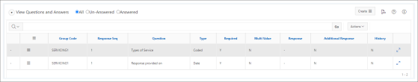

**Figure 25:** Example of the View Questions and Answers region

This region displays the current questions and answers relevant to the section or element in context and enables you to:

* Filter the records displayed
  + Use the All, Un-Answered or Answered buttons at the top of the region.
  + Use the Search Report at the top of the region.
* View the response history of a question

Click the Select this record icon to access the Response History region.



4.8 Appointment Details

Appointments are added to the diaries used for each housing officer, contractor site, inspector etc., together with details of a typical week pattern, including start times, end times and maximum number of appointments per day.

The Appointments region provides a historical view of this information and displays details such as, appointment start and end times, and appointment statuses.

4.8.1 Accessing the Appointments Region

To access the Appointments region where you can create and maintain appointments for a service, perform the following steps:

1. Navigate to the Services Details page.

For further information, see "Accessing the Services Details Page" on page 36.

1. Click the Appointments link at the top of the screen.

|  |
| --- |
| Tip:  If this link is not visible at the top of the screen, click More to expand the menu. |

The page refreshes to display the selected region.

You can now view all the appointments relevant to the service in context.

4.8.2 Appointments Region

This region displays the any historical appointment details for the selected record and enables you to:

* Access the Appointment Details page

Select Appointment Details from the Row Action list corresponding to the record you want to maintain.



* Break an appointment

Select Break Appointment from the Row Action list corresponding to the record you want to break the appointment for and make the necessary changes in the Break Appointment form.



* Cancel an appointment

Select Cancel Appointment from the Row Action list corresponding to the record you want to cancel the appointment for and make the necessary changes in the Cancel Appointment form.



* Complete an appointment

Select Complete Appointment from the Row Action list corresponding to the record you want to complete the appointment for and make the necessary changes in the Complete Appointment form.



* Create an appointment

Select Create Appointments from the Create list at the top of the region and enter the new details in the Create Appointments wizard.



* Move an appointment

Select Move Appointment from the Row Action list corresponding to the record you want to move the appointment for and make the necessary changes in the Move Appointment form.



* Record no access for an appointment

Select No Access For an Appointment from the Row Action list corresponding to the record you want to move the appointment for and make the necessary changes in the Record No Access For Appointment form.



* Update an appointment

Select Update Appointments from the Row Action list corresponding to the record you want to update and make the necessary changes in the Update Appointments form.



4.8.3 Create Appointments Wizard

This wizard consists of the following pages:

* Search Diary
* Select Diary
* Confirm Appointment

4.8.3.1 Search Diary

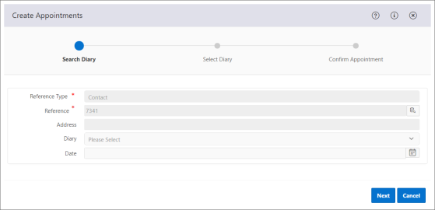

**Figure 26:** Example of the Create Appointments wizard Search Diary page

Use this page to record details such as the reference type and reference for which you are making the appointment.

This page contains the following fields:

* Reference Type *

Select the reference type value for the appointment.

This field may be automatically populated depending on where you accessed this wizard from.

* Reference *

Click the Open Search Page icon and search for the reference you want to make the appointment for.



This field may be automatically populated depending on where you accessed this wizard from.

* Address

The address of the property.

* Diary

Select the diary you want to make the appointment in.

|  |
| --- |
| Information:  You must select either a diary, a date or both to proceed.  If you select a diary or a diary and a date, you will go directly to the Confirm Appointment page when you click Next. |

* Date

Enter the date you want to make the appointment for.

If you have selected a diary in the Diary field, you can select the date and time you want to make the appointment for in the selected diary.

|  |
| --- |
| Information:  You must select either a date, a diary or both to proceed.  If you select a date and a diary, you will go directly to the Confirm Appointment page when you click Next. |

4.8.3.2 Select Diary

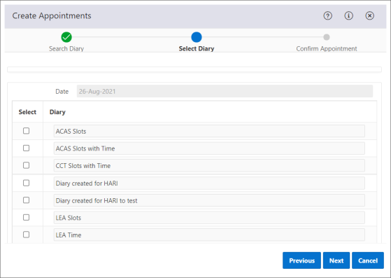

**Figure 27:** Example of the Create Appointments wizard Select Diary page

Use this page to select the diary in which you want to make the appointment.

This page contains the following fields:

* Date

The date on which you want to make the appointment.

* Select

Check the box corresponding to the diary you want to make the appointment in.

|  |
| --- |
| Information:  You can only check the Select box for one diary. |

* Diary

The diaries available to make the appointment in.

4.8.3.3 Confirm Appointment

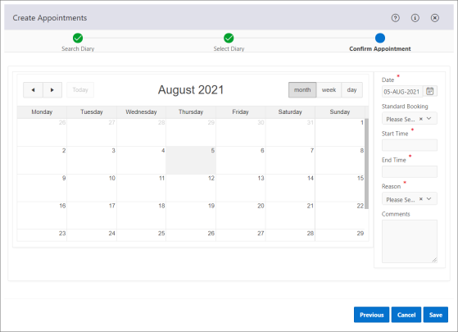

**Figure 28:** Example of the Create Appointments wizard Confirm Appointment page

This page contains two areas, Calendar and Appointment Details.

Calendar

You can use this calendar to pick a date for the appointment and to view pre-existing appointments and periods of unavailability prior to confirming the new appointment. This ensures there are no conflicts within the chosen diary.

The current date is highlighted along with any existing appointments and periods of unavailability.

Use the Previous and Next buttons at the top left-hand side of the appointment calendar to go back and forth through the calendar.



Click the Today button to return to the current date. This button is only active when the appointment calendar does not have the current date displayed.

Select one of the display options at the top right-hand side of the appointment calendar so you can view the calendar by month, week, or single day.

Appointment Details

What you will see in this area is determined by the options you have selected on the previous pages.

Use this area to make any adjustments necessary to the appointment details displayed.

|  |
| --- |
| Information:  If your organisation is using the Outlook 365 functionality, appointments created here are immediately added to your Outlook 365 calendar provided you have the same email address linked to Outlook 365 and your NEC Housing user account.  For further information on Outlook 365 integration contact NEC. |

This area contains the following fields:

* Date *

Adjust the date you want to make the appointment for.

* Standard Booking

Select the length of time for the appointment. For example, 1 hour, 2 hours etc.

This field is only available when the diary you have chosen is a time-based diary with standard bookings.

* Start Time *

Select or adjust the start time of the appointment.

* End Time *

Select the finishing time for the appointment.

This field may be automatically populated depending on the diary you have chosen.

* Units Available

The number of time units available within the appointment slot. For example, there could be four time units with an hour in each that combine to make one appointment slot.

This field is only available when the diary you have chosen uses appointment slots.

* Number of Units *

Enter the number of time units required for this appointment.

This field is only available when the diary you have chosen uses appointment slots.

* Reason *

Select the reason for making this appointment.

* Comments

Enter any additional information about the appointment. For example, if an applicant requires an interpreter for the appointment or to specify the type of boiler that should be fitted in a house.

4.9 Service Works Orders

A works order is an instruction to an operative to carry out day to day work to a property or an admin unit that is required as part of a service and can be made up of multiple job descriptions. The Works Orders region displays a list of the works orders that have been raised as a result of the creation of a service.

4.9.1 Accessing the Works Orders Region

To access the Works Orders region, perform the following steps:

1. Navigate to the Services Details page.

For further information, see "Accessing the Services Details Page" on page 36.

1. Click the Works Orders link at the top of the screen.

|  |
| --- |
| Tip:  If this link is not visible at the top of the screen, click More to expand the menu. |

The page refreshes to display the selected region.

You can now view details of the works orders that have been raised for the service in context.

4.9.2 Works Orders Region

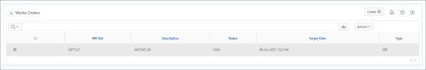

**Figure 29:** Example of the Works Orders region

This region displays the current works orders raised for the service in context and enables you to:

* Access the Works Order Details page

Select Works Order Details from the Row Action list corresponding to the record you want to maintain.



You can also:

* Filter the records displayed

Use the Search Report at the top of the region.

4.10 Attachments

The Attachments region allows your organisation to view all the documents, letters and images that relate to the record in context. This includes those documents that have been uploaded from Housing Online, the Contractor Portal, IAW (Information@Work) or a third-party document management system.

Information@Work Users

If the attachment you want to view the details for has a Communication Type of IAW Document, it will launch a web browser viewer that opens the document in a version of IAW (Information@Work) allowing you to view its details.

If user authentication has been enabled, you will automatically be logged into the Information@Work system. If you do not have an Information@Work user account, the first time you want to view the details for an attachment with a Communication Type of IAW Document (from NEC Housing), a new Information@Work user will be created. This new user account will have the default security level and security profile assigned to it. After creation, any further maintenance of the new Information@Work user should be carried out within the Information@Work system.

|  |
| --- |
| Note:  Where documents from other sources, such as within NEC Housing, are subsequently saved within IAW, the original document should be deleted or purged from the original source. Only one instance of the document should exist. |

Attachments with a Communication Type of Client Documents, Contractor Documents and Documents will open in an external NEC Housing document viewer. The document viewer acts as an electronic document management system (EDMS).

4.10.1 Accessing the Attachments Region

To access the Attachments region, perform the following steps:

1. Navigate to the Services Details page.

For further information, see "Accessing the Services Details Page" on page 36.

1. Click the Attachments link at the top of the screen.

|  |
| --- |
| Tip:  If this link is not visible at the top of the screen, click More to expand the menu. |

The page refreshes to display the selected region.

You can now view and maintain the attachments that have been uploaded for the service in context.

4.10.2 Attachments Region

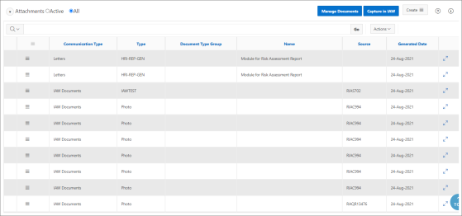

**Figure 30:** Example of the Attachments region

This region displays items attached to the selected record such as photographs and enables you to:

* Add a reference to a document

Select Add reference to a document from the Row Action list corresponding to the document you want to add a reference to and enter the relevant data in the Add reference to a document form.



* Browse the details of a letter

Select Browse Letter from the Row Action list corresponding to the record you want to browse.



|  |
| --- |
| Tip:  You can only perform this action if the Communication Type of the record selected is Letters. |

* Capture IAW documents

Click Capture in IAW at the top of the region to open and manage the document via Information@Work.

|  |
| --- |
| Info:  Any document captured in IAW here will not be made available for viewing in the Risk Management report. Please use the Upload Document action accessed from the Create list at the top of the region instead. |

* Delete an IAW record

Select Delete IAW Record from the Row Action list corresponding to the record you want to delete and confirm the deletion when prompted.



|  |
| --- |
| Tip:  You can only perform this action if the Communication Type of the record selected is IAW Documents. |

* Manage documents

Click Manage Documents at the top of the region and enter your search criteria in the Task Search Criteria form.

* Remove a document

Select Remove Document from the Row Action list corresponding to the record you want to remove and confirm the removal when prompted.



* Upload a document

Select Upload Document from the Create list at the top of the region and enter the necessary details in the Upload Document form.



|  |
| --- |
| Tip:  You can only perform this action if the details page you are using to visit the Attachments region has been integrated with Information@Work (IAW) or Filestore. |

* Upload a photo

Select Upload Document from the Create list at the top of the region and enter the necessary details in the Upload Document form.



|  |
| --- |
| Tip:  You can choose to compress the photo you want to upload by checking the Compress Image? field in the Upload Document form. |

* View document details

Select View Document from the Row Action list corresponding to the record you want to view the details for.



|  |
| --- |
| Tip:  You can only perform this action if the Communication Type of the record selected is Documents, IAW Documents or FileStore Documents. |

4.11 Contacts

The Contacts region allows you to view the contact details associated with the property or admin unit that is part of the service contract. These are the people that should be contacted if your organisation has the need to communicate with someone about the property or admin unit in regards to the service.

|  |
| --- |
| Note:  For properties the tenant contact details are needed, as well as the property contact details. |

4.11.1 Accessing the Contacts Region

To access the Contacts region where you can view the property/ admin unit contacts associated with the service, perform the following steps:

1. Navigate to the Services Details page.

For further information, see "Accessing the Services Details Page" on page 36.

1. Click the Contacts link at the top of the screen.

|  |
| --- |
| Tip:  If this link is not visible at the top of the screen, click More to expand the menu. |

The page refreshes to display the selected region.

You can now view the property/ admin unit contacts.

4.11.2 Contacts Region

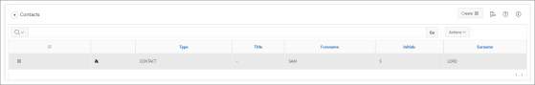

**Figure 31:** Example of the Contacts region

This region displays the current property/ admin unit contacts associated with the service in context and enables you to:

You can also:

* Filter the records displayed

Use the Search Report at the top of the region.

* View and maintain the contact details associated with the selected record

Click the Select this record icon to access the Contact Details region.



4.11.3 Accessing the Status History Region

To access the Status History region where you can view the history of the statuses recorded against a service, perform the following steps:

1. Navigate to the Services Details page.

For further information, see "Accessing the Services Details Page" on page 36.

1. Click the Status History link at the top of the screen.

|  |
| --- |
| Tip:  If this link is not visible at the top of the screen, click More to expand the menu. |

The page refreshes to display the selected region.

You can now view a history of the statuses that were applied to the service in context.

4.11.4 Status History Region

This region displays existing status history for the selected service and enables you to filter the records displayed using the Search Report at the top of the region.

Section 5: Servicing Imports

The Servicing module provides your organisation with the ability to directly import details as a convenient way of loading data from external sources. The ability to import data is an efficient method of loading property and admin unit element data from external sources.

|  |
| --- |
| Note:  You can only import property and admin unit elements into the Servicing module. |

5.1 Accessing the Imports Summary Page

To access the Imports summary page, do the following:

1. Click Housing.



The Housing menu expands.



1. Click Servicing .



The Servicing menu expands.



1. Click Imports.

The Imports summary page appears.

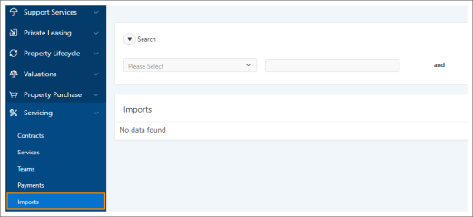

5.2 Imports Summary Page

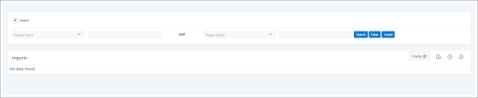

**Figure 32:** Example of the Imports summary page

This summary page is divided into two sections:

Search

|  |
| --- |
| In order to display records, you need to enter your search criteria in the Quick Search area at the top of the page and click the Search button. |

Imports Region

This region displays the records that meet your search criteria and enables you to import a file by selecting Import Files from the Create list at the top of the region and entering the details in the Import File form.



See 5.3 Import File Form on page 21 for details.

5.3 Import File Form



**Figure 33:** Example of the Import File form

This form contains the following fields:

* Type *

Select the type of file that you want to import.

|  |
| --- |
| Note:  For Servicing, when accessed from the Imports summary page, this will default to ELEMENT. However, if accessed from the Contract Addresses region, it defaults to ADDRESS. |

* File *

Click the Choose file button to search for and select the file you want to import.

* Allow multiple processing of files

When this field is not checked a named file previously loaded cannot be loaded again.

When checked, this allows a named file previously loaded to be loaded subsequently in the case for example of purposefully reloading corrected data sets.

* Overwrite or Merge Records *

Select an option to specify whether or not the records associated with this file should be overwritten or merged when imported into NEC Housing.

|  |
| --- |
| Note:  This is only applicable to Asset Management. |

Section 6: Reports and Processes

6.1 Run Batch Jobs

There are a number of batch jobs that are shipped with NEC Housing. The Run Batch Job region records information about a batch job or report that has been run upon a certain module. These batch jobs will be run according to the parameters and options you have previously specified in relation to that module.

6.2 Running Batch Jobs

To run a batch job, do the following:

1. Click GPI .



The GPI menu expands.

1. Click Run Job.

The Run Batch Job page appears.

1. Enter your search criteria in the Search area.

If the Quick Search options do not meet your needs, click the Advanced Search icon at the top of the Search area, and enter more specific criteria.



1. Click Search.

The recent jobs that meet your search criteria appear in the Run Batch Job region.

1. Select Run Module from the Row Action list corresponding to the module you want to run a job for.



The Run Module form appears.

1. Enter the relevant data in the form.
2. Click Save.

A message box appears.

1. Dismiss the message.

The form closes and you are returned to the Run Batch Job region.

The job will be run according to the parameters and options you have specified.

6.3 Run Module Form

This form contains the following areas:

Run Module Details

Table 1: Area Fields

| Field | Description |
| --- | --- |
| Module | The module name. |
| Audit Enabled | When set to Yes, audit is enabled. |
| Description | Description of the module. |
| Audit On | When set to Yes, audit is on. |
| Mod Type | The type of module. |
| Save Output | When set to Yes, the output of the module will be saved. |
| Output Format | The output format type for the module. |
| Wrap Length | The wrap length for the module. |

Parameters

Table 2: Area Fields

| Field | Description |
| --- | --- |
| Description | The parameter description. |
| Value | Enter or select the value for the parameter. |
| Batch modifier | Select the batch modifier for the parameter. |

Options

Table 3: Area Fields

| Field | Description |
| --- | --- |
| Run Type * | Select an option to specify the run type for this job:   * Immediate - to run the job immediately * Batch - to schedule the job on a batch queue. |
| Immediate Queue * | Select the queue the job is to be scheduled on from the list.   |  | | --- | | Note:  This field is only displayed when the run type Immediate has been selected in the Run Type field. | |
| Batch Queue * | Select the queue the job is to be scheduled on from the list.   |  | | --- | | Note:  This field is only displayed when the run type Batch has been selected in the Run Type field. | |
| Frequency * | Select the frequency at which the job is to be run from the list.   |  | | --- | | Note:  This field is only displayed when the run type Batch has been selected in the Run Type field. | |
| Start Date and Time * | Enter the date and time the first instance of the job is to be run.   |  | | --- | | Note:  This field is only displayed when the run type Batch has been selected in the Run Type field. | |
| End Date * | Enter the date the last instance of the job will be run.   |  | | --- | | Note:  This field is only displayed when the run type Batch has been selected in the Run Type field and Once only at this day/time has not been selected in the Frequency field. | |
| Print | When checked, the report should be printed immediately.   |  | | --- | | Note:  If you leave the print box unchecked, the report is sent to the batch scheduler, which generates a file that you can view and print at a later date. |  |  | | --- | | Tip:  Printing large reports increases printing times for other users. Before printing, check the size and content of the report. Very large reports can be scheduled to print outside of normal office hours. | |
| Copies | Select the number of copies to be printed from the list.   |  | | --- | | Restriction:  This field is only displayed when the Print box has been checked. |  |  | | --- | | Tip:  The default number of copies is one. | |
| Printer | Select the printer the output file is to be printed on from the list.   |  | | --- | | Restriction:  This field is only displayed when the Print box has been checked. | |
| Output File | Enter the name of the output file. |
| Output Directory | Select the output directory to which output files should be sent. |
| Save in DB | When checked, the process output files will be saved in the database.   |  | | --- | | Restriction:  This option is only available on a limited number of modules.  Where it is available, this function only acts on output files of a word processor type produced by DTI letters. |  |  | | --- | | Note:  Checking this box will save letters individually rather than in one long file. This allows individual letters to be viewed but will use more storage space. | |
| Debug Level | Select the debug level. |
| On Line | When checked, it is possible to view and edit the output online.   |  | | --- | | Restriction:  This option is only available on a limited number of modules.  Where it is available, the field is only displayed when Immediate has been selected in the Run Type field. | |
| Save Parameter Set | When checked, this parameter set will be saved so that any future jobs can be run according to the parameter values currently specified. |
| Public | When checked, the set is for public use. |
| Parameter Set Name | Enter the parameter set name. |

6.4 Generate Service Records Process

The Generate Service Records process will generate any outstanding services for all current contracts by using the service element date and the tolerance unit/ period that has been recorded against the contract.

Parameters

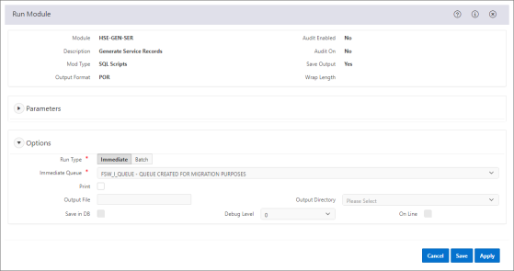

**Figure 34:**  Run Module form for the Generate Service Records process (HSE-GEN-SER)

This process does not have any parameters.

6.5 Module for Servicing Report (Generic)

The Module for Servicing Report (Generic) will generate a report from the details of a completed service record and any associated questions and answers.

When a service is completed, it's status is automatically set to 'COM'. From that point onwards the answers to the questions contained with each section cannot be changed. However, there may be a number of actions assigned to the service that still need to be completed and some of which may take some time to do.

Any updates to the actions associated with a completed service are recorded on the system enabling you to keep track of their progress.

Parameters

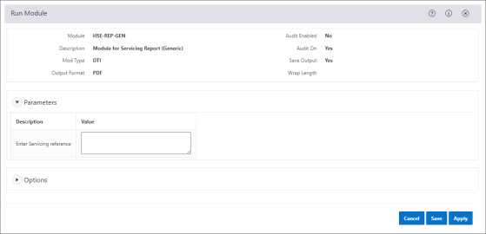

**Figure 35:** Screenshot of the Module for Servicing Report

Table 4: Parameter Fields

| Parameter | Description |
| --- | --- |
| Enter Servicing Reference | Enter the reference number of the service that you want to generate a current report for. |

6.6 Gas Safety Certificate for Landlords Report

The Gas Safety Certificate for Landlords report is used to produce a gas certificate for a landlord. The gas certificate is produced based on the answers to the question sections defined against the service type.

Parameters

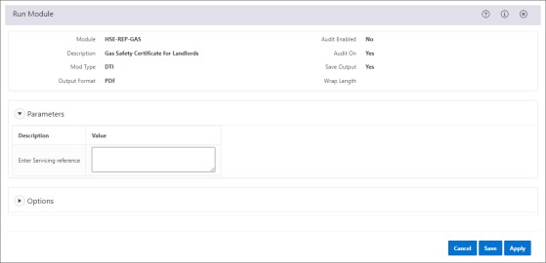

**Figure 36:** Screenshot of the Gas Safety Certificate for Landlords Report

Table 5: Parameter Fields

| Parameter | Description |
| --- | --- |
| Enter Servicing Reference | Enter the reference number of the service that you want to generate a current report for. |

6.7 EICR Certificate for Landlords Report

The EICR Certificate for Landlords report is used to produce an Electrical Inspection Condition Report 18th Edition. It is based on the answers to questions defined against a service type.

Parameters

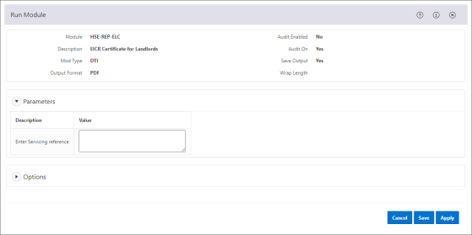

**Figure 37:** Screenshot of the Module for Servicing Report

Table 6: Parameter Fields

| Parameter | Description |
| --- | --- |
| Enter Servicing Reference | Enter the reference number of the service that you want to generate a current report for. |