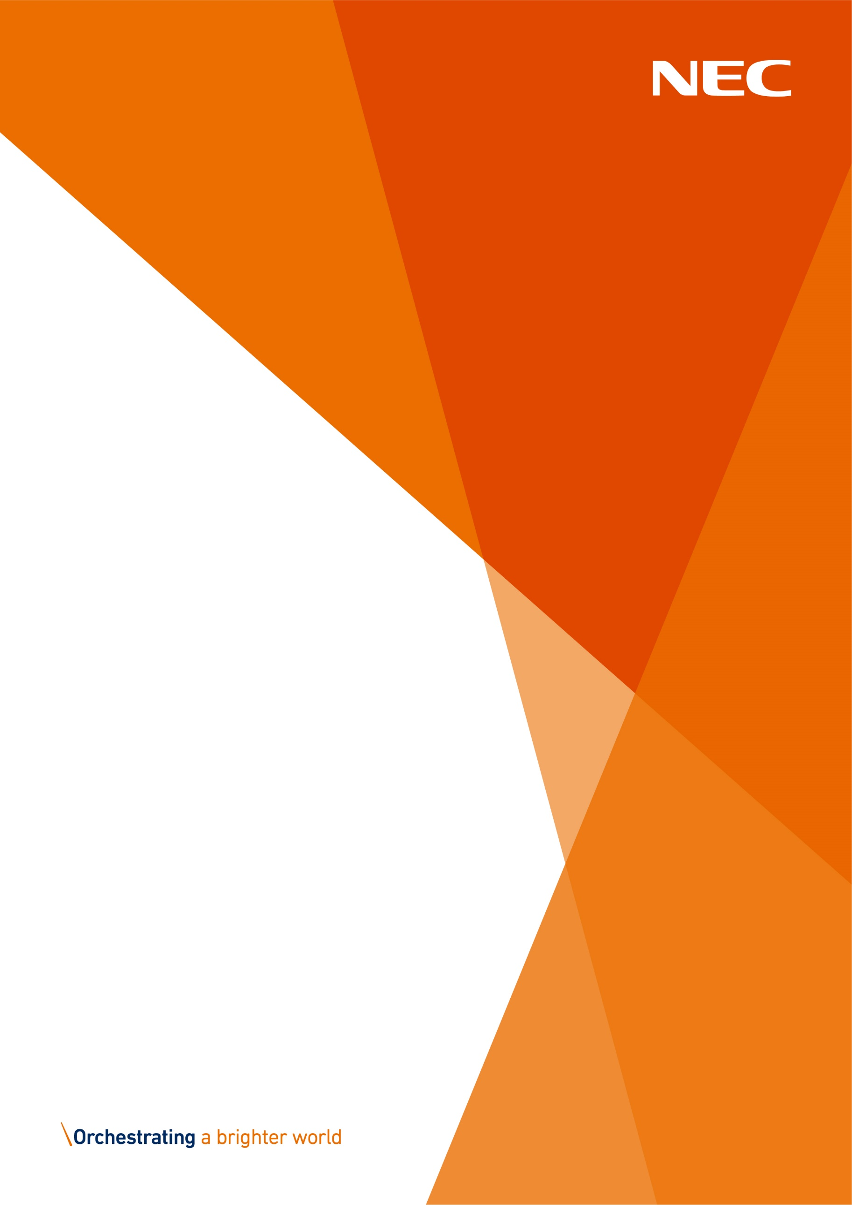
Software Release Bulletin
NECSWS.COM
Issue #709

For the attention of Revenues, Benefits and IT Managers

Contents
- Notification of RB7.00 Release

Notification of RB7.00 Release
We are pleased to announce the release of RB7.00 for all platforms. The software and installation notes are provided on the customer portal at:
https://customersupport.necsws.com/
Enter your username and password:
- Home Page
- My Products
- Revenues & Benefits
- Software
- Select <platform>.
The release note documents available are:
- R&B_7.00_Release_Information_v1.0.doc.
User guides that have been updated at this release for the rebranding to NEC are listed in the main release notes.
Please note that a guide has been specifically provided for the Version 7 updates and can also be found on the customer portal at:
- Home Page
- My Products
- Revenues & Benefits
- Documentation
- Select R&B Introduction to Version 7.0
Compatible Products
Customers should note that RB7.00 is compatible with:

Product | Version | Issued Date
Citizen Access – Revenues (hosted)  Citizen Access – Benefits (hosted)  Citizen Access – DHP (hosted) | NES_R280  NES_R290 | 8th July 2021 (PR)  28th October 2021 (PR)
Citizen Access – Landlord (hosted) | NOA_121 | 8th July 2021 (PR)
ScanPlus (also known as SHBE) | 7.00 | October 2021 with this RB release
Partnership Database | 6.18 | August 2018 – please note that the new user interface has been tested with this
Information @ Work | 5.11  5.22.10.10  5.30.20.3  5.31.10.0 | August 2018  June 2020  Nov 2020/May 2021  9th June 2021

RB Hosted Customers
All RB Hosted customers are advised to raise a service request to schedule the installation of this release.

De-support of IE11
As a reminder, from RB7.0.0, Internet Explorer 11 on the client is no longer supported. Also, in order to continue using DTI, DDE and 'New Window' modules in web browsers such as Edge and Chrome, your DBA must configure the web service versions of these modules by following the documentation available here: https://customersupport.necsws.com/products/revenues-benefits/?tab=documents&_sf_s=modern

Support of Previous RB Releases
Customers are reminded that the supported RB releases are the current release plus the previous release ONLY.
Following this release, RB7.1 is the year end release and this is currently scheduled to be delivered at the end of December 2021.

YourView 2021: We want to hear from you!

How satisfied are you with NEC Software Solutions?
Click here to start the survey

It should only take 5 - 10 minutes. For each completed response received by 12th November, a donation will be made to our nominated charities (Marie Curie and End Youth Homelessness)

Document Control
Author
Name | Contact details
Lynda Callaway | lynda.callaway@necsws.com

Authorisation
Role | Name | Date
Role | Name | Date
Product Management | Nigel Blair | 29-OCT-2021
Customer Support | Melitia Austin | 29-OCT-2021

Quality
NEC understands how important it is to receive good quality communications.
- Did this document clearly explain the issue?
- Did you understand what you needed to do?
- Were there any errors?
We would be very grateful for your feedback to nigel.blair@necsws.com
Any queries regarding the subject matter should be logged as calls as usual.
© 2021-present day, NEC Software Solutions UK Limited or one of its group companies. This document is protected by copyright laws in England and other countries and must not be copied, stored in a retrieval system or transmitted in any form or by any means in whole or in part without the prior written permission of NEC Software Solutions UK Limited.

